ANNEXURE ‘A’

[See rule 8]

AGREEMENT FOR SALE

THIS AGREEMENT FOR SALE (“Agreement”) is executed at Gurugram, on this ___________

BETWEEN

M/S ASHIANA HOUSING LIMITED,(PAN AADCA9093P) a company incorporated under the Companies Act, 1956, having its Registered Office at 5F, Everest, 46/C, Chowringhee Road, Kolkata – 700071 (West Bengal) and Local Office at __________________ (CIN-U70109WB1986PLC040864) through its Authorized Representative Mr. [▪]) duly authorized vide Resolution dated [▪] passed by the directors of the Company, (Copy enclosed as Annexure I) [hereinafter referred to as the “Promoter”, which expression shall unless it be repugnant to the context or meaning thereof be deemed to mean and include their legal successor(s), administrator(s), executor(s) & permitted assignee(s) including those of the respective partners] of the FIRST PART;

AND

[If the Allottee(s) is an Individual]

Mr./Ms./Mrs. [▪], Son/Daughter/Wife of Mr. [▪], R/o [▪] (Aadhar No. [▪]) (PAN [▪]) jointly with Mr./Ms./Mrs. [▪], Son/Daughter/Wife of Mr. [▪], R/o [▪] (Aadhar No. [▪]) (PAN [▪]); hereinafter singly/jointly referred to as the Allottee(s), which expression shall unless repugnant to the context or meaning thereof be deemed to mean and include their legal successor(s), administrator(s), executor(s) & permitted assignees) of the SECOND PART.

[OR]

[If the Allottee(s) is a Partnership]

[▪], a partnership firm registered under the Indian Partnership Act, 1932, having its principal place of business at [▪], (PAN No. [▪]), represented by its authorized partner [▪], (Aadhar No. [▪]) authorized vide [▪], (hereinafter referred to as the “Allottee(s)”, which expression shall unless repugnant to the context or meaning thereof be deemed to mean and include the partners or partner for the time being of the said firm, the survivor or survivors of them and their heirs, executors and administrators of the last surviving partner and his/ her/ their assigns) of the SECOND PART.

[OR]

[If the Allottee(s) is a Company]

[▪], (CIN No. [▪]) a company incorporated under the provisions of the Companies Act, [1956 or 2013, as the case may be], having its registered office at [▪], (PAN No. [▪]), represented by its authorized signatory [▪] (Aadhar No. [▪]) duly authorized vide board resolution dated [▪] (hereinafter referred to as the “Allottee(s)”, which expression shall unless repugnant to the context or meaning thereof be deemed to mean and include its successor-in-interest, executors, administrators and permitted assigns) of the SECOND PART.

[OR]

[If the Allottee(s) is a HUF]

Mr. [▪], (Aadhar No. [▪]) son of [▪] aged about [▪] for self and as the Karta of the Hindu Joint Mitakshara Family known as [▪] HUF, having its place of business / residence at [▪], (PAN No. [▪]) (hereinafter referred to as the “Allottee(s)”, which expression shall unless repugnant to the context or meaning thereof be deemed to mean and the members or member for the time being of the said HUF, and their respective heirs, executors, administrators and permitted assigns) of the SECOND PART

The “Promoter”, and the “Allottee(s)” shall hereinafter be collectively referred to as “Parties” and individually as “Party”

INTERPRETATIONS/DEFINITIONS

- In this Agreement, the following expressions unless repugnant to the context thereof shall have the meaning assigned thereto-

- “ACT” means Real Estate (Regulation & Development) Act, 2016.

- “ALLOTTEE(S)” means and includes:

- If the Allottee(s) is a Hindu Undivided Family, then its karta and each of the member constituting HUF, their heirs, executors, successors, administrators and permitted assignees;
- If the Allottee(s) is an individual then his/her legal successor(s), executor(s), administrator(s), legal representative(s), and permitted assignee(s);
- In case the Allottee(s) is a limited company, then its legal successor(s), representative(s) and permitted assignee(s); and
- In case the Allottee(s) is a Partnership Firm, then its partners for the time being, their respective legal successor(s), executor(s), administrator(s), legal representative(s) and permitted assignee(s) including those of the respective partners.

- “APARTMENT” shall mean a space in the Said Project/Whole Project intended and/or capable of being independently and exclusively occupied, having an entry and exit and includes a flat and all such units or spaces intended to be used for any residential or commercial use such as office, shop, convenient shopping in any part of the Said Project/Whole Project

- “APPLICABLE LAWS” shall mean all Acts, Rules and Regulations in force and in effect as of the date hereof as applicable in the State of Haryana including Haryana Urban Development Act, Haryana Urban Development Rules, Haryana Building Bye Laws, Real Estate (Regulation & Development) Act, 2016, Haryana Real Estate (Regulation and Development) Rules, 2017 and any other law which may be promulgated or brought into force and effect hereinafter including notifications, ordinances, policies, laws or orders or official directive of any Central/State Government or of any Statutory Authority in Haryana, as may be in force and effect during the subsistence of this Agreement and applicable to the development / construction / sale of the Said Project/Whole Project.

- “ARCHITECT” shall mean BIAS + Architecture and/or such other person(s) and/or firm(s) and/or company(s) whom the Promoter may appoint from time to time as the architect for the Said Project/Whole Project.

- “AUTHORITY” shall mean the Haryana Real Estate Regulatory Authority at Gurugram, Haryana.

- “BUILDING PLANS” shall mean the plans and designs of buildings constructed or to be constructed on the Entire Land which has been duly approved by the HSIIDC , Haryana vide Memo No. HSIIDC/IPD/IMT/M/2025/1050 dated 08.10.2025 including any variations therein which may subsequently be made by the Promoter and/or Architect(s) in accordance with Applicable Laws.

- “BUILDING” shall mean building No. / Tower No. in the Said Project/Whole Project where the Allottee(s) has been allotted his “Unit”.

- “CARPET AREA” means the net usable floor area of an Apartment, excluding the area covered by the external walls, areas under services shafts, exclusive balcony or verandah area and exclusive open terrace area but includes the area covered by the internal partition walls of the Apartment. Explanation.— For the purpose of this clause, the expression "exclusive balcony or verandah area" means the area of the balcony or verandah, as the case may be, which is appurtenant to the net usable floor area of an Apartment, meant for the exclusive use of the Allottee(s); and "exclusive open terrace area" means the area of open terrace which is appurtenant to the net usable floor area of an Apartment, meant for the exclusive use of the Allottee(s);

- “COMMON AREAS, AMENITIES AND FACILITIES OF THE WHOLE PROJECT” shall mean such common areas, amenities, facilities, equipment and spaces in the Whole Project meant for common use of and enjoyment of all the occupants of the Whole Project (as defined herein-below) and more particularly detailed in Part- I of Schedule- D attached hereto. However, such common areas, facilities, equipment and spaces shall be developed in different phases depending upon the phase in which they locate.

- “COMMON AREAS, AMENITIES AND FACILITIES RESERVED FOR RESIDENTIAL BLOCK” shall mean those common areas, amenities and facilities which are reserved for apartments under Residential Block in the Whole Project and as detailed in Part II of Schedule D.

- “COMMON AREAS, AMENITIES AND FACILITIES RESERVED FOR CONVENINENT SHOPPING BLOCK” shall mean those common areas, amenities and facilities which are reserved for Convenient Shopping Block to the exclusion of Residential Block in the Whole Project and as detailed in Part III of Schedule D.

- “COMMON AREAS, AMENITIES AND FACILITIES OF THE WHOLE PROJECT BEING DEVELOPED WITH THE SAID PROJECT” shall mean such common areas, amenities, facilities, equipment’s and spaces of the Whole Project which are to be developed with the Said Project and more particularly detailed in Part I of Schedule-E attached hereto.

- “COMMON AREAS, AMENITIES AND FACILITIES RESERVED FOR RESIDENTIAL BLOCK BEING DEVELOPED WITH THE SAID PROJECT” shall mean such common areas, amenities, facilities, equipment and spaces reserved for Residential Block which are to be developed with the Said Project and more particularly detailed in Part II of Schedule- E attached hereto.

- “COMMON AREAS, AMENITIES AND FACILITIES RESERVED FOR CONVIENENT SHOPPING BLOCK TO BE DEVELOPED WITH THE SAID PROJECT” shall mean such common areas, amenities, facilities, equipment’s and spaces reserved for Convenient Shopping Block which are to be developed with the Said Project and more particularly detailed in Part III of Schedule- E attached hereto.

- “CONVENIENT SHOPPING BLOCK” shall mean part of the Whole Project comprising of convenient shopping together with Common Area, Amenities and Facilities reserved for Convenient Shopping and being developed on Convenient Shopping Land as part of Ashiana Aaroham Phase I.

- “CONVENIENT SHOPPING BLOCK LAND” shall mean part and portion of the Entire Land admeasuring 217.896 sqm on which convenient shopping together with Common Area, Amenities and Facilities reserved for Convenient Shopping is being developed and marked in Part II of Schedule A.

- “DELAY PAYMENT CHARGES” means the charges payable by the Allottee(s) to the Promoter for delay in payment of any due amount, installment, charges etc. agreed to be paid under this Agreement, at the rate of State Bank of India highest marginal cost of lending Rate plus 2 (two) percent or such other rate as may be applicable from time to time as per the Act and Rules made thereunder.

- “EARNEST AMOUNT” shall mean 10% of the Total Price of the Unit.

- “ENTIRE LAND” shall mean land admeasuring 43708 sqm (10.80 acres ) Plot bearing No-GH-4, Sector-80, Manesar, Tehsil Manesar, District Gurugram, Haryana on which the Whole Project named Ashiana Aaroham, comprising of different phases is being developed and is demarcated and shown in Part I of Schedule- A.

- “INTEREST RATE” shall mean the interest payable by the Promoter to the Allottee at State Bank of India highest marginal cost of lending Rate plus two percent or such other rate as may be applicable from time to time as per the Act and Rules.

- “OWNERS ASSOCIATION” shall mean “Ashiana Aaroham Owners’ Association”, i.e., an association formed/to be formed by the owners of the units/Apartments in the Residential Block as per Clause (e) of Sub- Section (4) of Section 11 of the Act or a federation of Ashiana Aaroham Owners’ Association and the association formed as per Clause (e) of Sub- Section (4) of Section 11 of the Act, as the case may be.

- “PROJECT LAND” shall mean part of the Entire Land admeasuring 18849.79 sqm on which the Said Project is being developed and as shown in map in Part III of Schedule A.

- “REGULATION” shall mean the regulations made under the Act.

- “RESIDENTIAL BLOCK” shall mean part of the Whole Project comprising of building Tower No. 1 to 6 together with Common Area, Amenities and Facilities reserved for Residential Block and Common Areas, Amenities and Facilities of the Whole Project excluding convenient shopping block and as shown in the map in Part II of Schedule A.

- “RESIDENTIAL BLOCK LAND” shall mean part and portion of the Entire Land admeasuring 42492 sqm on which Residential Block together with Common Area, Amenities and Facilities reserved for Residential Block and Common Areas, Amenities and Facilities of the Whole Project is being developed in various phases and marked in Part II of Schedule A.

- “RULES” shall mean the Haryana Real Estate (Regulation and Development) Rules, 2017.

- “SAID PROJECT” shall mean Tower 3 and 4 of the Residential Block, Common Areas, Amenities and Facilities of the Whole Project being developed with Said Project as mentioned in Part I of Schedule E, Common Areas, Amenities and Facilities reserved for Residential Block being developed with Said Project and as mentioned in Part II of Schedule E, Convenient Shopping Block, Common Areas, Amenities and Facilities reserved for Convenient Shopping Block being developed with Said Project and as detailed in Part III of Schedule E being developed on the Project Land and named as Ashiana Aaroham Phase I.

- “SCHEDULE” shall mean the Schedules attached with this Agreement.

- “SECTION” means the section of the Act.

- “WHOLE PROJECT” shall mean the Residential Block, Convenient Shopping Block, Common Areas, Amenities and Facilities of the Whole Project as mentioned in Part I of Schedule D, Common Areas, Amenities and Facilities reserved for Residential Block as mentioned in Part II of Schedule D, Common Areas, Amenities and Facilities reserved for Convenient Shopping Block as mentioned in Part III of Schedule D named as “Ashiana Aaroham”.

- “HE OR HIS” shall also mean either she or her in case the Allottee(s) is a female or it or its in case the Allottee(s) is a partnership firm or a limited company.

- The words and expressions used herein but not defined in this Agreement and defined in the Act or in the Haryana Urban Development Act or any other law for the time being in force shall have the same meanings respectively assigned to them in those laws.

RECITALS:

- Promoter owns and possess a plot of land bearing no. GH-4 admeasuring 43,708 square meters, situated at Sector-80, Manesar, Tehsil Manesar, District Gurugram, Haryana (“the Plot”), allotted to it by Haryana State Industrial and Infrastructure Development Corporation Limited (“HSIIDC”), a Government of Haryana undertaking through a public auction conducted on 20th March 2023.

- HSIIDC issued a Letter of Intent bearing reference No. HSIIDC:C&H:2023:27 dated 28th March 2023 in favour of the Promoter. Subsequently, HSIIDC and the Promoter entered into a Registered Conveyance Deed dated 07th October 2024, whereby HSIIDC duly conveyed, transferred, and vested all rights, title, and interest in the Entire Land in favour of the Promoter. The said Conveyance Deed has been duly registered with the office of the Sub Registrar, Manesar, Haryana as Registration No.9168 in Book No. 1, Volume No. 377on Page No. 180 and pasted on Additional Book No. 1, Volume No. 3258 on Page No. 33 to 35(“Conveyance Deed’).

- The Promoter has divided the Entire Land into portions in the following manner and has demarcated the Entire Land in the map attached hereto as Part I of Schedule A:

- Residential Block Land(as defined in Clause I(26) of this Agreement) for the development of Residential Block (as defined in Clause I (25) of this Agreement);
- Convenient Shopping Block Land (as defined in Clause I (17) of this Agreement) for the development of Convenient Shopping Block (as defined in Clause I(16) of this Agreement);
- The Promoter has framed a scheme for developing the Whole Project comprising of Residential Block, Convenient Shopping Block all together with Common Areas, Amenities and Facilities of the Whole Project, Common Areas, Amenities and Facilities reserved for Residential Block and Common Areas, Amenities and Facilities reserved for Convenient Shopping Block as more particularly described in Part II of Schedule A to be known as “Ashiana Aaroham” on the Entire Land.

- However, for convenience and ease of construction, sales and marketing, the Whole Project has been divided and proposed to be developed into various phases with the clear intent to integrate all phases of Residential Block including Common Areas, Amenities, and Facilities for the Whole Project as mentioned in Part I of Schedule D and Common Areas, Amenities, and Facilities Reserved for Residential Block as mentioned in Part II of Schedule D into one upon completion of the Whole Project.

- The Promoter is in the process of constructing and developing the Said Project, being one of the phases of the Whole Project on the Project Land more fully described in Part II of Schedule A and forming part of the Entire Land.

- The common areas, facilities and amenities will be developed along with the phases or block in which they are located. Therefore, it has been clearly explained by the Promoter to the Allottee(s) and further understood and agreed by the Allottee(s) that the common areas, amenities and facilities would be developed in phases i.e. along with the phase of which such common area/facility/amenity is a part.

- It has been specifically explained by the Promoter and understood and agreed by the Allottee(s) that the allottees of the Whole Project shall have equal right in the Common Areas, Amenities and Facilities of the Whole Project as detailed in Part I of Schedule D. Accordingly, upon occupation of the Whole Project, Common Areas, Amenities and Facilities of the Whole Project as mentioned in Part I of Schedule D will be merged with all phases of Residential Block in the Whole Project which shall be free to use and exploit the Common Areas, Amenities and Facilities of the Whole Project as mentioned in Part I of Schedule D in common.

- The Promoter has further detailed the Common Areas, Amenities and Facilities of the Whole Project being developed with the Said Project in Part I of Schedule E, Common Areas, Amenities, and Facilities Reserved for Residential Block being developed with the Said Project are listed in Part II of Schedule E

- The Promoter has further detailed the Common Areas, Amenities and Facilities Reserved for Convenient Shopping Block in Part III of Schedule D and Common Areas, Amenities, and Facilities Reserved for Convenient Shopping Block being developed with the Said Project are listed in Part III of Schedule E

- The Promoter has obtained the final layout plan, Building Plan, and approvals for the Said Project from HSIIDC, Haryana. The Promoter agrees and undertakes that it shall not make any changes to these approved plans and permissions except in strict compliance with Section 14 of the Act and any other laws of the state of Haryana as applicable. The Promoter has further represented that it has obtained all necessary approvals and permissions as may be required for undertaking construction and development of the Said Project.

- Specifications of material used/to be used in construction of the Said Project have been specifically provided in Schedule-F attached hereto.

- The Promoter has registered the Said Project under the provisions of the Act with the Authority having registration No.117 of 2025.

- The Promoter is fully competent to enter into this Agreement and all the legal formalities with respect to the right, title and interest of the Promoter regarding the Project Land on which the Said Project is to be constructed.

- The Allottee(s) applied for an Apartment in Said Project and had paid/the application amount as mentioned in Part I of Schedule C, the receipt whereof is duly accepted by the Promoter. Consequently, vide an allotment letter, the Allottee has been allotted the Unit as more particularly described in Schedule B along with exclusive right to use open/ covered parking (if applicable), as permissible under the Applicable Laws (hereinafter referred to as the “Unit” and the floor plan of the Unit is annexed hereto and marked as Schedule B-1) and pro rata share in the Common Areas, Amenities and Facilities of the Whole Project and Common Areas, Amenities and Facilities reserved for Residential in the Said Project.

- The Allottee(s), being aware of the Said Project and details given above as well as in the brochure made available by the Promoter and/or on visiting the show home of an Apartment / Building and after satisfying themselves in all respects has applied for allotment and to purchase the Unit in the Said Project and deposited the booking amount and agrees to make timely and complete payments of the remaining Total Price as well as other dues under this Agreement as per terms and conditions of this Agreement and as per the Payment Plan mentioned in Part II of Schedule C. It is clarified that there are different kinds of apartments conceptualized in the Said Project which may not be the same as show home, which the Allottee(s) have understood and acknowledged. The Promoter represents that the show home is for representational purposes only and is created to give a look and feel of an Apartment in the Said Project.

- On demand from the Allottee(s), the Promoter has given inspection to the Allottee(s) of all the documents of title relating to the Project Land/Entire Land and the plans (including the Building Plans), designs and Specifications prepared by the Promoter's Architect and of such other documents as are specified under the Act and the Rules and Regulations made thereunder. The Allottee(s) directly, or through their lawyer, have reviewed these documents and have fully satisfied themselves as to the title of the Promoter as well as the layout, design and specifications of the Said Project.

- The Allottee(s) hereby confirms that the Promoter has handed over to the Allottee(s), a draft of this Agreement along with all Schedules and Annexures before purchasing the Unit and after reading and having understood the mutual rights and obligations detailed herein along with all Schedules and Annexures, the Allottee(s) is/ are entering into this Agreement for purchase of the said Unit. The Parties hereby confirm that they are signing this Agreement with full knowledge of all Applicable Laws, applicable to the Said Project/Whole Project.

- The Parties, relying on the confirmations, representations, and assurances of each other to faithfully abide by all the terms, conditions and stipulations contained in this Agreement and Applicable Laws, are now willing to enter into this Agreement on the terms and conditions appearing hereinafter.

- In accordance with the terms and conditions set out in this Agreement and as mutually agreed upon by and between the Parties, the Promoter hereby agrees to sell and the Allottee(s) hereby agrees to purchase the said Unit.

NOW THIS AGREEMENT WITNESSETH AND THE PARTIES HERETO MUTUALLY AGREE ON FOLLOWING TERMS AND CONDITIONS, NAMELY:

TERMS:

  - Subject to the terms & conditions as detailed in this Agreement, the Promoter hereby agrees to sell to the Allottee(s) and the Allottee(s) hereby agrees to purchase the Unit more specifically described in Schedule B hereunder.

  - The Total Price of the Unit based on the carpet area of the Unit (“Total Price”) is more particularly described in Part I of Schedule C hereunder.

The Total Price above includes the application/advance amount paid by the Allottee(s) to the Promoter towards the Unit as mentioned in Part I of Schedule C. All Other Charges, which are specifically mentioned in this Agreement in Clause 1.8 does not form part of the Total Price and shall be paid by the Allottee(s) in addition to Total Price as per this Agreement.

  - Total Price is inclusive of taxes, including but not limited to GST and Cess or any other similar taxes which may be levied, in connection with the construction of the Said Project.

Provided that in case there is any change/ modification/introduction of new taxes, the subsequent amount payable by the Allottee(s) to the Promoter shall be increased/ reduced based on such change/ modification/introduction. The Promoter shall provide to the Allottee(s) the details of change/ modification/introduction in taxes, which is paid or demanded along with the Acts/rules/notifications together with dates from which such taxes/levies etc. have been imposed or become effective

Provided further, that if there is any increase in the taxes after the expiry of the scheduled date of completion of the Said Project as per registration with the Authority, which shall include the extension of registration, if any, granted to the Said Project by the Authority, as per the Act, the same shall not be charged from the Allottee(s).

  - The Promoter represents that External Development Charges (EDC) and Infrastructural Development Charges (IDC) for the external services provided by the Haryana Government in relation to Said Project and Common Areas, Amenities and Facilities of the Whole Project forms part of the Total Price calculated as per the present rate. Promoter further represents that if in future, there is any increase in the External Development Charges and/or Infrastructural Development Charges or the Haryana Government levies additional charges toward EDC and IDC or such similar charges in relation to Said Project and Common Areas, Amenities and Facilities of the Whole Project, the same shall be payable by the Allottee(s)to the Promoter on demand on proportionate basis.

The Total Price is escalation free, save and except increases which the Allottee(s) hereby agrees to pay, due to increase on account of development charges payable to the competent authority and/or any other increase in charges/taxes/levies or introduction of new charges/levies/taxes which may be levied or imposed by the competent authority, from time to time. The Promoter undertakes and agrees that while raising a demand on the Allottee(s) for increase in development charges, cost/charges/taxes imposed by the competent authorities, the Promoter shall enclose the said notification/ order/ rules/ regulations to that effect along with the demand letter being issued to the Allottee(s), which shall only be applicable on subsequent payments.

Provided that if there is any new imposition or increase of any development charges after the expiry of the scheduled date of completion of the Said Project as per registration with the Authority, which shall include the extension of registration, if any, granted to the Said Project by the Authority, as per the Act, the same shall not be charged from the Allottee(s).

  - The Total Price of Unit includes proportionate price of land under Residential Block Land, construction of, not only the Unit but also, the Common Areas, Amenities and Facilities of the Whole Project and Common Areas, Amenities and Facilities Reserved for Residential Block, EDC, IDC, cost of providing electric wiring, electrical connectivity to the Unit, lift, water line and plumbing, finishing with paint, marbles, tiles, doors, windows, fire detection and firefighting equipment in the Common Areas, Amenities and Facilities of the Whole Project and Common Areas, Amenities and Facilities reserved for Residential Block, etc. and includes cost for providing all other facilities, amenities and specification as agreed to be provided by the Promoter to the Allottee(s)within the Unit and the Said Project. It is clarified that the Total Price does not include proportionate price of Convenient Shopping Block Land and the Common Areas, Amenities and Facilities Reserved for Convenient Shopping Block.

  - The Allottee(s) shall make the payment of the Total Price as per the payment plan set out in Part II of Schedule C (“Payment Plan”). The Promoter shall periodically intimate to the Allottee(s), the amount payable as stated in Part I of Schedule C as per the Payment Plan provided in Part II of Schedule C hereunder and the Allottee(s) shall make payment demanded by the Promoter within the time and in the manner specified therein.

  - The Allottee(s) shall be liable for all costs, charges and expenses [subject to maximum of Rs. 25,000/- (Rupees [Twenty Five Thousand only) in connection with the costs of the preparing, executing and registering of this Agreement or related agreements, conveyance deed / sale deed and any other document or documents required to be executed by the Promoter in favor of the Allottee(s) in respect of sale/transfer of the said Unit in favor of the Allottee. These charges are in addition to the stamp duty and registration charges to be paid by the Allottee(s) for getting the agreement and sale deed /conveyance deed registered.

  - The Allottee(s) shall be liable to pay maintenance deposit, upfront maintenance charges, water charges (if any), stamp duty and registration charges applicable at the time of registration of this Agreement, conveyance deed, etc. in respect of the Unit, which shall be exclusively borne and paid by the Allottee(s).

  - The Allottee(s) has to deduct the applicable tax deduction at source (TDS) at the time of making of actual payment as per section 194IA of the Income Tax Act, 1961. Any failure to deduct or deposit TDS would attract interest and penalty as per provisions of Income Tax Act, 1961. The Allottee(s) shall submit the original TDS certificate in the prescribed timelines mentioned in the Income Tax Act, 1961. If the Allottee(s) fails to submit the TDS certificate to the Promoter on the TDS deducted within the stipulated timelines as per Income Tax Act, the Allottee(s) shall be liable to pay penalty as per provisions of Income Tax Act, 1961 and the Allottee(s) shall keep the Promoter indemnified in this regard. Notwithstanding anything stated in this Clause, default in payment of TDS or providing certificate of deposit of TDS would deem to mean a default in the payment of installment of the Total Price under this Agreement and the consequences thereof, as mentioned herein shall follow,

  - The Promoter represents that it shall not make any additions and alterations in the Building Plans, layout plans and specifications and the nature of fixtures, fittings and amenities described therein at Schedule–F in respect of the Unit/Said Project/Building without the previous written consent of the required number of the Allottee(s) as prescribed under the Act (as may be amended from time to time) and the Allottee(s) hereby agrees that such consent shall not be unreasonably withheld. Provided that the Promoter may make such minor additions or alterations as may be required by the allottee(s), or such minor changes or alterations as may be necessary due to architectural and structural reasons duly recommended and verified by an authorized Architect or Engineer or by any competent authority after proper declaration and intimation to the Allottee(s) as per the provisions of Section 14 of the Act.

  - The Promoter shall confirm to the final Carpet Area that has been allotted to the Allottee(s) after the construction of the Building is complete and the Occupancy Certificate is granted by the competent authority, by furnishing details of the changes, if any, in the Carpet Area. The Total Price payable for the Carpet Area shall be recalculated upon confirmation by the Promoter. If there is reduction in the Carpet Area which is not more than 5% (five percent) of the Carpet Area of the Unit, then the Promoter shall refund the excess money paid by Allottee(s) within 90 days with interest from the date when such an excess amount was paid by the Allottee(s). If there is any increase in the Carpet Area which is not more than 5% (five percent) of the Carpet Area of the Unit, allotted to the Allottee(s), the Promoter may demand that from the Allottee(s) along with the next milestone of the Payment Plan as provided in this Agreement. All these monetary adjustments whether refund or payment shall be made on the basis of Carpet Area. Further Carpet Area shall be measured from brick to brick.

  - Subject to Clause 9.3, the Promoter agrees and acknowledges that the Allottee(s) shall have the right to the Unit as mentioned below:

    - The Allottee(s) shall have exclusive ownership of the Unit.
    - The Allottee(s) shall also have undivided proportionate share in the Common Areas, Amenities and Facilities of the Whole Project and Common Areas, Amenities and Facilities of the Residential Block. Since the share/ interest of Allottee(s) in the Common Areas, Amenities and Facilities of the Whole Project and Common Areas, Amenities and Facilities of the Residential Block is indivisible and cannot be divided or separated, the Allottee(s) shall use the Common Areas, Amenities and Facilities of the Whole Project and Common Areas, Amenities and Facilities of the Residential Block along with other occupants and maintenance staff etc., without causing any inconvenience or hindrance to them. It is clarified that the Promoter shall handover the Common Areas, Amenities and Facilities of the Whole Project along with Common Areas, Amenities and Facilities reserved for Residential Block to the Owners Association or its nominees or the maintenance agency after duly obtaining the Occupancy Certificate from the competent authority.
    - That the computation of the Total Price of the Unit includes recovery of price of land, construction of, not only the Unit but also, the Common Areas, Amenities and Facilities of the Whole Project and Common Areas, Amenities and Facilities of the Residential Block, internal development charges, external development charges, cost of providing electric wiring, electrical connectivity to the Unit, lift, water line and plumbing, finishing with paint, marbles, tiles, doors, windows, fire detection and firefighting equipment in the Common Areas, Amenities and Facilities of the Whole Project and Common Areas, Amenities and Facilities of the Residential Block, maintenance charges for 3 (three) months from the date of Occupation Certificate and includes cost for providing all other facilities, amenities and specification to be provided within the Unit and the Said Project as detailed in Schedule F.
    - To assess the extent of development of the Said Project and his Unit, the Allottee(s) may visit the Said Project. However, the Promoter discourages such kind of visit by the Allottee(s) and his/her family members due to the risk at construction site. If the Allottee(s) decides to visit site, he/she shall take due care and proper safety measures while visiting the site as construction activities will be in full swing and the Promoter shall not in any way be held responsible for any accident, fall of any object, mishappening etc. caused to/with Allottee(s) and his/her accompanying persons while using the site. Further, the Promoter strictly prohibits the visit of children at construction site.

  - The Allottee(s) understands that the Whole Project comprises of open and covered vehicle parking spaces spread across the Whole Project. Parking spaces for the residents of Residential Block are earmarked within the Residential Block.

  - For day-to-day comfort of all the residents of the Residential Block, the Promoter has earmarked parking space for the exclusive use of each unit in the Residential Block without charging any consideration thereof. Further, the Allottee(s) understands and agrees that every allottee(s) of the Residential Block will be entitled to 2(Two) parking duly earmarked and some units maybe earmarked with more than 2 (Two) parking. The parking so earmarked and the unallotted vehicle parking space in the Residential Block shall form part of the Common Areas, Amenities and Facilities reserved for Residential Block.

  - The Allottee(s) understands that in order to maintain the administration of the Whole Project / Residential Block /Said Project, the Promoter has earmarked the vehicle parking spaces and the Allottee(s) undertakes to park his vehicle strictly in the parking space earmarked to him and not anywhere else in the Whole Project and/or Said Project and/or Residential Block. The parking space earmarked to the Allottee(s) shall be meant exclusively for parking of specific number of vehicles and under no circumstances the Allottee(s) will be allowed to park vehicles more than the parking space earmarked for him or anywhere else in the Whole Project and/or Said Project and/or Residential Block. Further the Allottee(s) agrees that the Promoter or the Owners Association reserves the right to restrict the entry of additional vehicles owned by the Allottee(s) within the Whole Project and/or Residential Block and/or the Said Project exceeding number of parking spaces earmarked. The Promoter has informed the Allottee(s) and the Allottee(s) has agreed that the parking spaces are distributed in the Residential Block and shall be developed in a phased wise manner. It may happen that in a phase there may not be sufficient parking spaces as compared to the number of units developed in a particular phase or with the objective of providing convenience of customers , allottee may be earmarked with parking in subsequent or previous phases. In such a condition, the Promoter shall make temporary arrangements for parking the vehicles till the time permanent parking spaces are earmarked in other phases of the Residential Block. Further, the Allottee(s) of other phases may also be earmarked parking space in the Said Project by the Promoter and the Allottee(s) shall not have any objection to this.

  - It is made clear by the Promoter and the Allottee(s) agrees that the Unit including the garage/covered parking, if allotted shall be treated as a single indivisible unit for all purposes. It is agreed that the Whole Project is an independent, self-contained Project covering the Entire Land and is not a part of any other project or zone and shall not form a part of and/or linked/combined with any other project in its vicinity or otherwise except for the purpose of integration of infrastructure for the benefit of the Allottee(s). It is clarified that Project’s facilities and amenities shall be available only for use and enjoyment of the Allottee(s) of the Whole Project.

  - The Allottee(s) agrees and understands that except the Unit as described in Schedule-B attached hereto, the Allottee(s) shall have no ownership claim or right of any nature in respect of any un-allotted saleable / leasable area in the Said Project/Residential Block/Whole Project. Such un-allotted saleable / leasable spaces shall remain the exclusive property of the Promoter, which it shall be free to deal with, in accordance with Applicable Laws. Nursery School developed in the Whole Project will be used for the Whole Project as its common facility and will be common for all the residents of the Whole Project.
  - The Promoter has already received an advance/ application amount from the Allottee(s) as mentioned in Part I of Schedule C and the Allottee(s) agrees and undertakes to pay the balance amount strictly in accordance with the payment plan given in Part II Schedule - C attached hereto.

Provided that if the Allottee(s) delays in payment towards any amount which is payable as per this Agreement, he shall be liable to pay Delay Payment Charges. The Allottee(s) is aware that the taxes including GST on the Delay Payment Charges shall also be borne and paid by the Allottee.

  - The Promoter shall be exclusively entitled to install its signage, hoarding, any other kind of branding for its any past, present and future project at any suitable place in the Said Project / Residential Block / Whole Project and the Allottee(s) and the Owners Association shall not have or shall not obstruct on exploitation of this right by the Promoter.

  - Lawn Area, terrace, parking, storages or any other area exclusively earmarked for a particular Apartment (s) by the Promoter shall form part of Limited Common Areas and Facilities reserved for exclusive use and enjoyment of owner/occupant of that Apartment to the exclusion of other Allottees.

  - The Allottee(s) hereby agrees and acknowledges that the Promoter shall not be under any obligation to provide any services and/or facilities except as specifically mentioned in this Agreement.

  - The Promoter agrees to pay all outgoings/ dues till the offer of physical possession of the Unit to the Allottee(s) towards payment of all governmental dues, rates, charges and taxes and other monies, levies, impositions, premiums, damages and/or penalties and other outgoings, whatsoever, payable with respect to the Project. If the Promoter fails to pay all or any of the outgoings/ dues, the Promoter agrees to be liable, even after the transfer of the Unit, to pay such outgoings/ dues and penal charges, if any, to the authority or person to whom they are payable and be liable for the cost of any legal proceedings which may be taken therefore by such authority or person.

  - The Promoter further represents and the Allottee(s) is aware that the Whole Project is being developed in phases and the Promoter will have the right to access to the Said Project / Residential Block / Whole Project till the completion of all the phases for construction and sale/lease of the Apartments and the other saleable/leasable areas in future phases.

Provided that after transferring the possession of the Common Area, Amenities, and Facilities of the Whole Project and the Common Area, Amenities, and Facilities reserved for the Residential Block to the Owners Association, the Promoter shall continue to have the rights and entitlements to advertise, market, sell any Apartment or building which is not sold without any restrictions or hindrance from the Owners Association and sale proceeds thereof shall belong only to the Promoter and such Allottee(s)shall be included as members of the Owners Association.

  - The bifurcation and demarcation of the Common Areas, Amenities and Facilities in the Whole Project has been done by the Promoter however if in future the court of law pass any order against such bifurcation and demarcation of Common Areas, Amenities and Facilities of the Whole Project and considers such bifurcation and demarcation, illegal, the Allottee(s) will have to abide by the order of such court of law.

  - While sanctioning the Building Plans, HSIIDC has laid down certain terms, conditions, stipulations, and restrictions which are to be observed and performed by the Promoter while developing the Whole Project on Entire Land and upon due observance and performance of which only the occupation or occupancy certificate in respect of the said Building / Said Project shall be granted by the concerned local authority.

MODE OF PAYMENT:

Subject to the terms of the Agreement and the Promoter abiding by the construction milestones, the Allottee(s) shall make all payments, on written demand by the Promoter, within the stipulated time as mentioned in the Payment Plan given in Part II of Schedule- C hereunder through account payee cheque/ demand draft/ banker's cheque or online payment (as applicable) in favor of ASHIANA HOUSING LIMITED AAROHAM PH-1 MASTER COLLECTION A/c 008305019638 payable at Gurugram. The Promoter has opened a separate account in ICICI Bank in Branch Gurugram of ICICI Bank for the purpose as provided in sub-clause (D) of clause (1) of sub-section (2) of section 4 of the Act.

COMPLIANCE OF LAWS RELATING TO REMITTANCES:

  - The Allottee(s), if resident outside India, shall be solely responsible for complying with the necessary formalities as laid down in Foreign Exchange Management Act,1999 ('FEMA'), Reserve Bank of India Act, 1934 ('RBI' Act) and the rules and regulation made thereunder or any statutory amendments or modifications made thereof and all others applicable laws including that of remittance of payment, acquisition/ sale/ transfer of immovable properties in India etc. and provide the Promoter with such permission, approval which would enable the Promoter to fulfill its obligations under this Agreement. Any refund, transfer of security, if provided in terms of the Agreement shall be made in accordance with the provisions of FEMA or statutory enactments or amendments thereof and the rules and regulation of the Reserve Bank of India or any other applicable law. The Allottee(s) understands and agrees that in the event of any failure on his/ her part to comply with the applicable guidelines issued by the Reserve Bank of India, he/ she may be liable for any action under FEMA or other laws as applicable, as amended from time to time.

  - The Promoter accepts no responsibility in regard to matters specified in Clause 3.1 above. The Allottee(s) shall keep the Promoter fully indemnified and harmless in this regard. Whenever there is any change in the residential status of the Allottee(s) subsequent to the signing of this Agreement, it shall be the sole responsibility of the Allottee(s) to intimate the same in writing to the Promoter immediately and comply with necessary formalities if any, under the Applicable Laws. The Promoter shall not be responsible towards any third party making payment/remittances on behalf of Allottee(s) and such third party shall not have any right in the application/allotment of the Unit in any way and the Promoter shall be issuing the payment receipts in favor of the Allottee(s) only.

ADJUSTEMENT/ APPROPRIATION OF PAYMENTS:

The Allottee(s) hereby authorizes the Promoter to adjust/ appropriate all payments made by him/ her under any head of dues against lawful outstanding of the Allottee(s) against the Unit, if any, in his/ her name and the Allottee(s) undertakes not to object/ demand/ direct the Promoter to adjust his payments in any manner.

TIME IS ESSENCE:

The Promoter shall abide by the time scheduled for completing the Said Project & receipt of Occupancy Certificate i.e. 31st July 2030 and for the completion of whole project as disclosed at the time of registration of the Said Project with the Authority and towards handing over the Unit to the Allottee(s) and the Common Areas, Amenities and Facilities of the Whole Project and the Common Areas, Amenities and Facilities Reserved for the Residential Block to the Owners Association.

Notwithstanding anything contained in this Agreement, timely performance by the Allottee(s) of all its obligations under this Agreement, including without limitation, the obligations to make timely payments of all the dues (including the Total Price of the Unit) as well as other dues, deposits and amounts, including payment of any Delay Payment Charges, in accordance with this Agreement and the Act and the Rules shall also be the essence of this Agreement.

CONSTRUCTION OF THE SAID PROJECT:

  - The Allottee(s) has seen the layout plan, Building Plan, specifications, amenities and facilities of the Said Project and accepted the floor plan, Payment Plan and the specification, amenities and facilities annexed along with this Agreement which has been approved by the competent authority, as represented by the Promoter. The Promoter shall develop the Said Project in accordance with the said layout plans, Building Plan, floor plans and specifications, amenities and facilities. Subject to the terms in this Agreement, the Promoter undertakes to strictly abide by such plans approved by the competent authorities and shall also strictly abide by the bye-laws, FAR, and density norms and provisions prescribed by the relevant building bye-laws and shall not have an option to make any variation/ alteration/ modification in such plans, other than in the manner provided under the Act and the procedure agreed hereunder, and breach of this term by the Promoter shall constitute a material breach of this Agreement.

  - It is clarified and the Allottee(s) agrees that the appropriate Government Authority has an obligation and responsibility to provide the external linkages for services and amenities beyond the boundaries of the Whole Project (including, in relation to roads, water lines, sewage, storm water drains and electricity) and in the event the Government Authority body fails to provide the external linkages for such services and amenities, including road, water lines, sewage, storm water disposal and electricity by the time of offers possession of the Unit to the Allottee(s), the Promoter shall make arrangements (to the extent possible) to provide such external linkages for appropriate road connectivity, water supply through tankers or otherwise, and electricity supply through DG sets, the charges for which shall be payable by the Allottee(s) to be calculated on the basis of actual cost including applicable taxes plus a reasonable mark-up.

  - The Allottee(s) understands that the development of the Whole Project is taking place in a phased wise manner, as a result of which, Promoter may obtain requisite approvals for the development of the other phases to be developed in the Whole Project from the Government Authority from time to time. The Allottee(s) understands and consents to the development of the other phases in the Whole Project to be undertaken by Promoter and the Allottee(s) waives his right to raise objections in relation to any inconvenience caused due to the construction of the other phases in the Whole Project. However, the development of the other phases shall not result in any change of the specifications, size of the Unit; or entail payment of additional consideration / charges by the Allottee(s); or result in any increase in the number of apartments in the Whole Project.

POSSESSION OF SAID APARTMENT:

  - Schedule for possession of the Unit – The Promoter agrees and understands that timely delivery of possession of the Unit to the Allottee(s) along with the Common Areas, Amenities and Facilities of the Whole Project being developed with Said Project as mentioned in Part I of Schedule E and Common Areas, Amenities and Facilities Reserved for Residential Block being developed with Said Project as mentioned in Part II of Schedule E to the Owners Association, is the essence of the Agreement. The Promoter assures to handover possession of the Unit along with the Common Areas, Amenities and Facilities of the Whole Project being developed with Said Project as mentioned in Part I of Schedule E and Common Areas, Amenities and Facilities Reserved for Residential Block being developed with Said Project as mentioned in Part II of Schedule E with all Specifications as detailed in Schedule F in place, on or before 31st July 2030. unless there is delay or failure to keep the construction going due to war, flood, drought, fire, cyclone earthquake, pandemic, epidemic, lockdown, or any other calamity caused by nature, or due to any order by any Court, Tribunal or Government Authority, quasi judicial body, effecting the regular development of the Said Project (“Force Majeure”). The Promoter shall obtain the Occupancy Certificate on or before 31st July 2030 and shall obtain Completion Certificate on or before 30th October 2033. If, however, the completion of Said Project is delayed due to the Force Majeure conditions then the Allottee(s) agrees that the Promoter shall be entitled to the extension of time for delivery of possession of the Unit along with along with the Common Areas, Amenities and Facilities of the Whole Project being developed with Said Project as mentioned in Part I of Schedule E and Common Areas, Amenities and Facilities Reserved for Residential Block being developed with Said Project as mentioned in Part II of Schedule E and the Promoter shall not be liable to pay any penalty/interest/compensation for the delay caused due to such Force Majeure condition. Provided that such Force Majeure conditions are not of a nature which makes it impossible for this Agreement to be implemented. The Allottee(s) agrees and confirms that, in the event it becomes impossible for the Promoter to implement the Said Project or any part thereof, due to Force Majeure conditions, which shall be assessed by the Promoter, the Promoter shall inform the Allottee(s) about such impossibility along with notice of termination of 1 (one) month. In such a scenario, the Allottee(s) agrees to execute (and register) a cancellation deed with respect to the Unit on which date, the termination shall become effective. Upon termination of this Agreement, the Promoter shall refund to the Allottee(s) the entire amount received by the Promoter from the Allottee(s), without any interest, within 45 (forty-five) days from the date on and only after which the amount will be refunded to the Allottee. After refund of the money paid by the Allottee(s), the Allottee(s) agrees that he/ she shall not have any rights, claims etc. against the Promoter and/or the Said Project and the Promoter shall be released and discharged from all its obligations and liabilities under this Agreement. However, the aforesaid amount shall be refunded by the Promoter only upon execution and registration of the cancellation deed by the Allottee.

  - Procedure for taking possession- The Promoter, upon obtaining the Occupancy Certificate from the competent authority shall issue an offer letter (“Offer Letter”) in writing offering to hand over possession of the Unit, to the Allottee(s) and requesting the Allottee(s) to come forward and execute and register the Conveyance Deed in terms of this Agreement. Within 20 (twenty) days from the date of Offer Letter, the Allottee(s) shall make payment of all dues, outstanding, interest, if any, maintenance security stamp duty, registration charges, documentation charges, etc. to the Promoter and within 50 (fifty) days from clearance of entire dues, outstanding, etc., the Allottee(s) shall take physical possession of the Unit and simultaneously get conveyance of his Unit done from the Promoter by getting the conveyance deed/sale deed registered before the Sub Registrar. After the expiry of 3 (Three) full calendar months from the date of issue of Occupancy Certificate i.e Deemed Date of Possession the Allottee(s) shall be liable to pay the maintenance charges as determined by the Promoter / Owners Association / maintenance agency, as the case may be. The Promoter shall handover the copy of Occupancy Certificate of the Said Project / Building to the Allottee(s) at the time of conveyance of the same. The Promoter agrees and undertakes to indemnify the Allottee(s) in case of failure of fulfillment of any of the provisions, formalities, documentation on the part of the Promoter which the Promoter is liable to comply/carry out as per the Applicable Laws provided such failure is not on account of reasons beyond the controls of Promoter and/or on account of any default/delay on the part of the Allottee(s). The Allottee(s) shall be solely responsible and liable for compliance of the provisions of Indian Stamp Act, 1899, Haryana Stamp Act and Registration Act, 1908 including any actions taken or deficiencies/penalties imposed by the competent authority. After the Deemed Date of Possession, the Promoter shall not be responsible for any damage caused to the Unit on account of delay on the part of the Allottee(s) in taking over possession and in such event the Allottee(s) shall have to take possession of the same on “as is where is basis”. The Promoter shall not be held responsible in any manner for any future mishaps like fire, earthquake, flood etc. or any accident caused due to any of machineries installed like electrical equipment, and transformer, etc.

  - Possession of the common areas to the Allottee(s)- After obtaining the Occupancy Certificate of the Said Project, it shall be the responsibility of the Promoter to handover the necessary documents and plan, including Common Areas, Amenities and Facilities of the Whole Project being developed with Said Project as mentioned in Part I of Schedule E and Common Areas, Amenities and Facilities Reserved for Residential Block being developed with Said Project as mentioned in Part II of Schedule E to the Owners Association within 30 (thirty) days after obtaining the Occupancy Certificate.

  - Cancellation by Allottee(s)- The Allottee(s) shall have the right to cancel/withdraw his allotment in the Said Project as provided in the Act:

Provided that where the Allottee(s) proposes to cancel/withdraw from the Said Project without any fault of the Promoter, or before the date of completion of the Said Project as recorded with the Authority at the time of registration of the Said Project or any extension thereof, the Promoter shall be entitled to forfeit and retain the Earnest Amount, stamp duty, registration charges etc. paid in respect of allotment of the Unit and execution & registration of cancellation deed in favor of the Allottee; Delay Payment Charges; documentation charges as mentioned in this Agreement, charges (including taxes) for dishonor of cheque (if any) by the Allottee(s) and all amounts collected as taxes, charges, levies, cess, assessments and all other impositions which may be levied by any appropriate authorities including but not limited to, GST, to the extent that credit of the GST / taxes paid is not allowed to be claimed as refund by the Promoter and all amounts (including taxes) paid or payable as brokerage fee to any real estate agent, broker, channel partner, institution etc. by the Promoter in respect of the booking of the Allottee(s) etc., as on the date of such termination, from the amounts paid by the Allottee(s) till such date and the balance amount of money paid by the Allottee(s), if any, shall be returned by the Promoter to the Allottee(s) without any interest, from the amount realized from new allottee. After refund of the money paid by the Allottee(s) as provided in this Clause, the Allottee(s) agrees that it shall not have any rights, claims etc. against the Promoter and the Promoter shall be released and discharged from all its obligations and liabilities under this Agreement. However, the aforesaid amount shall be refunded by the Promoter only upon execution and registration of the cancellation deed by the Allottee.

Cancellation by Allottee(s) after Occupancy Certificate- Where the Allottee(s) proposes to cancel/withdraw from the Said Project without any fault of the Promoter, after receipt of Occupancy Certificate of the Said Project, the Promoter shall be entitled to forfeit and retain twice the Earnest Amount, stamp duty, registration charges etc. paid in respect of allotment of the Unit in favor of the Allottee; Delay Payment Charges; documentation charges as mentioned in this Agreement, charges (including taxes) for dishonor of cheque (if any) by the Allottee(s)and all amounts collected as taxes, charges, levies, cess, assessments and all other impositions which may be levied by any appropriate authorities including but not limited to, GST, to the extent that credit of the GST / taxes paid is not allowed to be claimed as refund by the Promoter and all amounts (including taxes) paid or payable as brokerage fee to any real estate agent, broker, channel partner, institution etc. as on the date of such termination, from the amounts paid by the Allottee(s) till such date and the balance amount of money paid by the Allottee(s), if any, shall be returned by the Promoter to the Allottee(s) without any interest, from the amount realized from new allottee. After refund of the money paid by the Allottee(s) as provided in this Clause, the Allottee(s) agrees that it shall not have any rights, claims etc. against the Promoter and the Promoter shall be released and discharged from all its obligations and liabilities under this Agreement. However, the aforesaid amount shall be refunded by the Promoter only upon execution and registration of the cancellation deed by the Allottee.

  - Compensation – The Promoter shall compensate the Allottee(s) in case of any actual loss, caused to him due to defective title of the Project Land, on which the Said Project is being developed or has been developed, in the manner as provided under the Act and the claim for the interest and compensation under this provision shall not be barred by limitation provided under any law for the time being in force.

Except for occurrence of a Force Majeure event, if the Promoter fails to complete or is unable to give possession of the Unit (i) in accordance with the terms of this Agreement, duly completed by the day specified in Clause 7.1 above; or (ii) due to discontinuance of his business as a developer on account of suspension or revocation or expiry of the registration of the Said Project under the provisions of the Act; or for any other reason; the Promoter shall be liable, on demand to the Allottee(s), in case the Allottee(s) wishes to withdraw from the Said Project, without prejudice to any other remedy available, to return the total amount received by the Promoter in respect of the Unit, with interest calculated at Interest Rate including compensation in the manner as provided under the Act within 90 (ninety) days from the date of cancellation of the Agreement:

Provided that if the Allottee(s) does not intend to withdraw from the Said Project, the Promoter shall pay the Allottee(s) interest computed at Interest Rate for every month of delay, till the handing over of the possession of the Unit, which shall be paid by the Promoter to the Allottee(s) within 90 (ninety) days of it be coming due.

  - Conveyance - The Allottee(s) shall be liable to pay from the date of Deemed Date of Possession or date of actual possession, whichever is earlier, house-tax, property-tax, fire-fighting tax or any other fee, cess or tax as applicable under Applicable Law, as and when levied by any local body or authority and so long as the Unit of the Allottee(s) is not separately assessed to such taxes, fees or cess, the same shall be paid by the Allottee(s) in proportion to the Carpet Area of Unit. If the Promoter has to pay the aforesaid amounts on the behalf of the Allottee(s), the Allottee(s) shall be liable to reimburse the same to the Promoter within 15 days from the date of notice in this regard from the Promoter failing which the Promoter shall be entitled to charge Delay Payment Charges for the period commencing on the date on which the Promoter paid the said amounts to the concerned authorities and ending on the date on which the Allottee(s) pays the said amounts to the Promoter. Promoter shall notify the date(s) for the purpose of execution and/or registration of the conveyance deed in favour of the Allottee. The Allottee(s) agrees and undertakes to make him available and present before the competent registering authority for the said purpose on the date(s) communicated to him. In the event that the execution of the conveyance deed is delayed for any reason whatsoever, the Allottee(s) alone shall be liable to pay any increase in stamp duty, registration charges and other like charges before the execution of the conveyance deed. In case the Allottee(s) has taken any loan from any bank/ financial institution for the Unit, the original transfer documents including the conveyance deed shall be directly handed over by Promoter to the lending institution, if so required by them.

REPRESENTATIONS AND WARRANTIES OF THE PROMOTER

The Promoter hereby represents and warrants to the Allottee(s) as follows:
- The Promoter has absolute, clear and marketable title with respect to the Entire Land and the requisite rights to carry out development upon the Entire Land and has absolute, actual, physical and legal possession of the Entire Land for the Whole Project.
- The Promoter has lawful rights and requisite approvals from the competent authorities to carry out development of the Whole Project.
- Except those mentioned in this Agreement, there are no encumbrances upon the Entire Land or the Whole Project.
- All approvals, licenses and permits issued by the competent authorities with respect to the Whole Project, Entire Land and Unit are valid and subsisting and have been obtained by following due process of law. Further, the Promoter has been and shall, at all times, remain in compliance with all Applicable Laws in relation to the Whole Project, Unit and Common Areas, Amenities and Facilities of Whole Project.
- The Promoter has the right to enter into this Agreement and has not committed or omitted to perform any act or thing, whereby the right, title and interest of the Allottee(s) created herein, may prejudicially be affected.
- The Promoter has not entered into any agreement for sale and/or development agreement or any other agreement or arrangement with any person or party with respect to the Entire Land, including the Project Land and the Unit which will, in any manner, affect the rights of Allottee(s) under this Agreement.
- The Promoter confirms that the Promoter is not restricted in any manner whatsoever from selling the Unit to the Allottee(s) in the manner contemplated in this Agreement.
- At the time of execution of the conveyance deed, the Promoter shall handover lawful, vacant, peaceful, physical possession of the Unit to the Allottee(s) and the Common Areas, Amenities and Facilities of the Whole Project to be developed with the Said Project and Common Areas, Amenities and Facilities reserved for the Residential Block to be developed with Said Project to the Owners Association.
- The Entire Land is not the subject matters of any HUF and that no part thereof is owned by any minor and /or no minor has any right, title and claim over the Entire Land.
- The Promoter has duly paid and shall continue to pay and discharge all governmental dues, rates, charges and taxes and other monies, levies, impositions, premiums, damages and/or penalties and other outgoings, whatsoever ,payable with respect to the Said Project to the Competent Authorities till Occupancy Certificate has been issued and possession of the Unit along with Common Areas, Amenities and Facilities of the Whole Project to be developed with the Said Project and Common Areas, Amenities and Facilities reserved for the Residential Block to be developed with Said Project (equipped with all specifications, amenities and facilities) has been handed over to the Allottee(s) and Owners Association.
- No notice from the Government or any other local body or authority or any legislative enactment, government ordinance, order, notification (including any notice for acquisition or requisition of the property) has been received by or served upon the Promoter in respect of the Entire Land and/or the Whole Project.
- The Promoter has obtained assurance letter dated 21.03.2024 from Gurugram Metropolitan Development Authority (GMDA) for supply potable/drinking water for the Whole Project. Promoter further represents that till such time such water is made available by GMDA to the Whole Project and water becomes available for the Said Project/Whole Project, the requirement of water for the Said Project/Whole Project shall be met from other available sources including procurement of water from water tanker agencies and that a pro-rata share incurred for such purchase and treatment thereof shall be borne and paid by the Allottees. The Allottee(s) acknowledges the same and agrees to make the payment towards the same in addition to the monthly maintenance charges.
- Notwithstanding anything contained in this Agreement, the Allottee(s) covenant that if the Promoter is required to refund any amount to the Allottee(s) due to any reason whatsoever, the Promoter shall have no liability to refund any taxes, levies, duties, charges, cess, duties etc. paid to any government authority.

- The Allottee(s) hereby agrees and undertakes to be a member of the Owners Association and to sign and execute the application for registration, other papers and documents necessary for the formation of and registration of such Owners Association. The Allottee(s) shall observe and perform all the rules, regulations of the Owners Association that may be specified in detail by the Owners Association. The Allottee(s) shall also pay and contribute regularly and punctually towards all charges, costs, fees, subscription or other out-goings as may be demanded or called upon by the Owners Association or the Maintenance Agency, as the case may be.

EVENTS OF DEFAULTS AND CONSEQUENCES:

  - Promoter’s Default- Subject to the Force Majeure, the Promoter shall be considered under a condition of default, in the following events, namely: -

    - The Promoter fails to provide ready to move in possession of the Unit to the Allottee(s) without any default on the part of the Allottee(s), within the time period specified in Clause 7.1 above in this Agreement. For the purpose of this clause, 'ready to move in possession' shall mean that the Unit shall be in a habitable condition which is complete in all respects including the provision of all specifications as agreed to between the Parties and as specified in Schedule F and for which Occupation Certificate, has been issued by the competent authority;
    - Discontinuance of the Promoter's business as a developer on account of suspension or revocation or expiry of the registration of the Said Project under the provisions of the Act or the rules or regulations made thereunder.

  - In case of default by the Promoter under the conditions listed above, Allottee(s) is entitled, subject to the condition that there is no default on the part of the Allottee(s), to the following:

    - Stop making further payments to the Promoter as demanded by the Promoter. If the Allottee(s) stops making payments, the Promoter shall correct the situation by completing the construction/ development milestones and only thereafter the Allottee(s) be required to make the next payment without any delay payment charges; or
    - The Allottee(s) shall have the option of terminating the Agreement in which case the Promoter shall be liable to refund the entire money paid by the Allottee(s) under any head whatsoever towards the purchase of the Unit, along with interest calculated at Interest Rate within 90 (ninety) days of receiving the termination notice:

Provided that where an Allottee(s) does not intend to withdraw from the Project or terminate the Agreement, he shall be paid, by the Promoter, interest calculated at Interest Rate for the period of delay till the handing over of the possession of the Unit, which shall be paid by the Promoter to the Allottee(s) within ninety (90) days of it becoming due.

  - Allottee’s Default- The Allottee(s) shall be considered having committed a default, on the occurrence of any one or more of the following events:

    - Failure on the part of the Allottee(s) to make payment of any installment as per the Payment Plan, despite having been issued notice in that regard;
    - Delay/default by Allottee(s) under Clause 9.3.1 continues for a period beyond 2 consecutive months after demand notice from the Promoter in this regard;
    - After the issuance of Offer Letter as per Clause 7.2, failure on the part of the Allottee(s) to deposit the stamp duty/registration charges/any other amounts due including Delay Payment Charges, if applicable, under this Agreement within the period mentioned in the Offer Letter;
    - After the issuance of Offer Letter as per Clause 7.2 the delay/failure on the part of the Allottee(s), having paid all the amounts due to the Promoter under this Agreement, in execution and registration of conveyance deed of the Unit and/or taking possession of Unit within the period mentioned in Offer Letter;
    - Breach of any other terms & conditions of this Agreement on the part of the Allottee(s);
    - Violation of any of the Applicable Laws on the part of the Allottee(s).

  - The Promoter’s rights/remedies upon occurrence of any of event of default on the part of the Allottee(s) as mentioned in Clause 9.3 above shall be as follows:

    - Upon occurrence of event of default mentioned in Clause 9.3.1 the Allottee(s) shall be liable to pay Delay Payment Charges on the overdue amounts for the period commencing from the date on which such overdue amounts or part thereof were due to be paid by the Allottee(s) to the Promoter and ending on the date of the payment of such overdue amounts by the Allottee(s) to the Promoter;
    - Upon occurrence of event of default mentioned in Clause 9.3.2 the Promoter may cancel the allotment by terminating this Agreement by serving a notice of 30 days to the Allottee(s) in this regard;
    - Upon occurrence of event of default mentioned in Clause 9.3.3, 9.3.4 9.3.5 and 9.3.6 the Promoter shall have the option to terminate this Agreement as mentioned in Clause 9.4.2; Further in case of event of default under Clause 9.3.3, till the time Promoter exercises the option to terminate this Agreement it shall be entitled to (a) recover Delay Payment Charges as per Clause 9.4.1 and (b) recover maintenance charges from the Deemed Date of Possession; (c) recover holding/ safeguarding charges @0.1% per month on the Total Price of the Unit; (d) taxes mentioned in Clause 7.4; (e); withhold registration of the conveyance deed of the Unit in favor of the Allottee(s); and to refuse possession of Unit to the Allottee(s) till payment of amounts mentioned in Clause 9.3.3 is received and Allottee(s) hereby authorizes the Promoter for the same. The rights and remedies of the Promoter under this Clause shall be in addition to other rights and remedies available to the Promoter under Applicable Laws, equity and under this Agreement. Further, acceptance of any payment without Delay Payment Charges shall not be deemed to be a waiver by the Promoter of its right of charging such Delay Payment Charges or of the other rights mentioned in this Agreement.

  - Upon termination of this Agreement by the Promoter as mentioned hereinabove, the Allottee(s) shall not have any lien, right, title, interest, or claim in respect of the Unit. The Promoter shall be entitled to sell the Unit to any other person or otherwise deal with the Unit in any manner whatsoever and the Promoter shall be entitled to forfeit / deduct the following amounts out of the amounts paid by the Allottee(s) and refund the balance to the Allottee(s) without any interest:

    - Earnest Amount,
    - Delay Payment Charges;
    - Documentation charges as mentioned in this Agreement,
    - Charges (including taxes) for dishonor of cheque (if any) by the Allottee;
    - All amounts collected as taxes, charges, levies, cess, assessments and all other impositions which may be levied by any appropriate authorities including but not limited to, GST, to the extent that credit of the GST / taxes paid is not allowed to be claimed as refund by the Promoter; and
    - All amounts (including taxes) paid or payable as brokerage fee to any real estate agent, broker, channel partner, institution etc.;

  - Without prejudice to the rights of the Promoter under this Agreement, the Promoter shall be entitled to file/initiate appropriate complaint/proceedings against the Allottee(s) under the Act for default/breach of any of the terms and conditions of this Agreement or the provisions of the Act/ Rules/Regulations.

MAINTENANCE OF THE SAID PROJECT:

  - That one of the factors for the Allottee(s) to buy unit in Whole Project is that the Promoter is known for appropriate standards of maintenance and management services in relation to its project through an independent agency Ashiana Maintenance Services, LLP (“Maintenance Agency”). Maintenance Agency has very rich and vast experience and expertise in the management and maintenance of large size high rise residential projects having all modern equipment’s, amenities and facilities such as club house, swimming pool, gym, STP, power back up system, reticulated pipe gas network, CCTV surveillance system or other modern security system, lifts, horticulture etc. The Allottee(s) is aware that due to qualitative and cost-effective maintenance of its projects, the Maintenance Agency is able to maintain the beauty and aesthetic look of its projects consistently which not only increases the life of its projects but gives appreciation to the value of the projects. Apart from qualitative maintenance of the project, Maintenance Agency organizes various sports, cultural and festive activities from time to time for the benefit and enjoyment of the residents which ultimately provides a good lifestyle to the residents. The Allottee(s) understands that other Allottees have also booked/bought units in its projects because of the above characteristics of Maintenance Agency Accordingly, the Maintenance Agency is being appointed to carry out the maintenance of the Whole Project at competitive prices until its appointment is recalled, and another maintenance agency is appointed after notice period of six months by the Owners Association through a majority resolution. It is made clear that Maintenance Agency is a separate legal entity which has been engaged specifically for the purposes set out herein above and shall continue to operate as a maintenance agency for the project till such time that the majority of the members of the Owners Association deems it fit. The role of Maintenance Agency is strictly confined to the extent set out in the maintenance agreement to be executed for the Whole Project and the Promoter is merely facilitating the process of maintaining the project through the said agency. It is made clear that the Promoter and Maintenance Agency have separate, independent and distinct roles in the project and neither shall be deemed to represent the other in the project. The nomenclatures ‘Management Agency’ and ‘Promoter’ have been consciously employed in this agreement to highlight the exclusivity and variance in the roles played by each party and at no point of time can the Promoter be held liable for the actions of the Management Agency and vice-versa. The Promoter has engaged the services of Management Agency for the maintenance and management of the Whole Project for the limited purposes of ensuring that the Allottees continue to enjoy the services for which they have booked a unit in the Whole Project. The Management Agency shall serve purely at the pleasure of the majority of the members of the Owners Association, which is at full liberty to recall the services of Management Agency through a majority resolution, if it so deems, without any reference to or concurrence with the Promoter.
  - The Promoter, upon the receipt of Occupancy Certificate, shall hand over the possession of the Common Areas, Amenities and Facilities of the Whole Project being developed with Said Project as mentioned in Part I of Schedule E and Common Areas, Amenities, and Facilities reserved for Residential Block being developed with the Said Project as mentioned in Part II of Schedule E to the Owners Association in accordance with the Applicable Laws.

  - In terms of the provisions of the Act, process will be initiated to form Owners Association of the Owners of the Units at the appropriate time by the name of “Ashiana Aaroham Owners’ Association”, under Haryana laws for the Residential Blocks in the Whole Project. Ashiana Aaroham Owners’ Association will have a set of bye laws (hereafter referred to as "Bye- Laws") which shall govern the Owners Association of the Residential Block and the members of the Owners Association i.e. the unit owners in the Residential Block. All the owners of units/apartments in the Residential Block shall become members of Ashiana Aaroham Owners’ Association by payment of membership fees and shall abide by the Bye-Laws of the Ashiana Aaroham Owners’ Association. The Allottee(s) shall become member of the Ashiana Aaroham Owners’ Association by signing necessary forms/documents for the Unit and hereby undertakes to comply with the Byelaws in letter and spirit.

  - The Allottee(s) hereby agrees that his/her right to the use of Common Areas. Amenities and Facilities Reserved for Residential Block and Common Areas, Amenities and Facilities of the Whole Project shall be subject to timely payment of total maintenance charges and performance by the Allottee(s) of all his/her obligations in respect of the terms and conditions specified under this Agreement as well as by the Owners Association from time to time. The Allottee(s) undertakes to pay such provisional monthly contribution and such proportionate share of outgoings including water charges regularly each month in advance and shall not withhold the same for any reason whatsoever. It is agreed that the non-payment or default in payment of outgoings on time by Allottee(s) shall be regarded as the default on the part of the Allottee(s) and shall entitle the Promoter to terminate this agreement in accordance with the terms and conditions contained herein.

  - Allottee(s) shall be bound by all the terms and conditions of the Agreement of Owners Association, Bye- Laws, maintenance agreement and any other agreement entered by the Owners Association and any decisions taken by the Owners Association as per its Byelaws.

DEFECT LIABILITY:

  - It is agreed that in case any structural defect or any other defect in workmanship, quality or provision of services or any other obligations of the Promoter as per this Agreement relating to such development is brought to the notice of the Promoter within a period of five (5) years by the Allottee(s) from the date of handing over possession or Deemed Date Of Possession, whichever is earlier, it shall be the duty of the Promoter to rectify such defects without further charge, within thirty (30) days, and in the event of Promoter's failure to rectify such defects within such time, the aggrieved Allottee(s) shall be entitled to receive appropriate compensation in the manner as provided under the Act.

  - In case any such structural defect or any other defect in workmanship, quality or provision of services reasonably & in the ordinary course requires additional time beyond the said 30 (thirty) days having regard to the nature of the defect, then Promoter shall be entitled to such additional time period, provided, an intimation thereof has been provided to the Allottee, prior to the expiry of the said initial 30 (thirty) days. The Parties shall mutually work upon and agree to a reasonable and justifiable additional time period for rectification of such defects. The Allottee(s)hereby agrees to such additional time / extension of time without being entitled to or making any claim to receive appropriate compensation in the manner provided under the Act and / or otherwise under Applicable Law.

  - Promoter shall not be liable for rectification of any defect if the same has resulted due to natural wear and tear, alterations, misuse, and deviation from conditions of usage, and any act, omission or negligence attributable to the Allottee(s)or the Owner’s Association. Intrinsically, breakable or degradable items like tiles, stones, wooden items, glass, aluminum items, façade, doors and windows and such like shall not be covered under Defect Liability and the same shall not rectified by the Promoter.

  - The Allottee(s) confirms and agrees that all fittings, fixtures etc. shall be made functional at the time of handing over the possession of the Unit but the maintenance thereof shall be the responsibility of the Allottee. The Allottee(s) further understands that there is a fundamental difference between hand over of the building / constructions or infrastructure services and systems free from defects on the one hand and requirement of timely, appropriate and adequate maintenance of handed over building / constructions or infrastructure services and systems so as to maintain aesthetic appearance and / or defect free functioning which by its very nature is a lifelong process. Accordingly, the continued maintenance including consumables and spare parts of the systems handed over would not be the responsibility of the Promoter, and the Promoter shall not be liable for rectification of any defects resulting from improper or lack of timely maintenance.

INDEMNIFICATION

  - The Allottee(s) shall, without prejudice to any other rights of the Promoter, agrees to indemnify and keep fully indemnified, hold harmless and defend the Promoter, from and against third party claims, demands, actions, suits, proceedings, judgments, orders, damages, costs, losses and expenses of any nature whatsoever brought against the Promoter or which the Promoter may suffer or incur due to or by reason of the Allottee(s) making, committing, causing or permitting to be made or committed any default or breach in respect of or non- observance or non-compliance with:

    - any of the provisions/covenants of this Agreement; and/or
    - any representation or warranties or covenants of the Allottee(s) being false or incorrect; and/or
    - any other claim, cost or damage directly attributable to the obligations of the Allottee(s) under the Agreement or due to failure/delay of the Allottee(s) to comply with its obligations under the applicable Central and/or State and local laws and/or of any of the provisions of this Agreement; and/or
    - termination of this Agreement by the Allottee(s) without any default/delay on the part of the Promoter; and/or
    - due to failure of the Allottee(s) to execute and deliver this Agreement to the Promoter within the time prescribed in Clause 29; and/or
    - due to failure of the Allottee(s) to appear before the sub-registrar for registration of this Agreement as per Clause 28;and/or
    - termination of this Agreement by the Promoter due to any default/delay on the part of the Allottee(s).

  - The Parties acknowledge that the foregoing indemnities shall survive the termination of this Agreement.

  - The indemnification rights of the Promoter under this Clause shall be in addition to any other rights and remedies available to the Promoter under Applicable Laws, equity and this Agreement.

RIGHT TO ENTER THE UNIT FOR REPAIRS:

The Promoter/ Owners Association shall have right of unrestricted access of all common areas, garages/covered parking and parking spaces for providing necessary maintenance services and the Allottee(s) agrees to permit the Promoter/ Owners Association/ to enter into the Unit or any part thereof, after due notice and during the normal working hours, unless the circumstances warrant otherwise, with a view to set right any defect.

USAGE:

  - Use of Basement(s) and service areas: - The basement and service areas, if any, as located within the Said Project / Whole Project, shall be earmarked for purposes such as parking spaces and services including but not limited to electric sub-station, transformer, DG set rooms, underground water tanks, pump rooms, maintenance and service rooms, firefighting pumps and equipment etc. and other permitted uses as per sanctioned plans. The Allottee(s) shall not be permitted to use the services areas and the basements in any manner whatsoever, other than those earmarked as parking spaces, and the same shall be reserved for use by the Owners Association for rendering maintenance services.

GENRAL COMPLIANCE WITH RESPECT TO THE UNIT:

  - Subject to Clause 11 above, the Allottee(s) shall, after taking possession, be solely responsible to maintain the Unit at his/her own cost, in good repair and condition and shall not do or suffer to be done anything in or to the Unit, or the staircases, lifts, common passages, corridors, circulation areas, atrium or compound which may be in violation of any laws or rules of any authority or change or alter or make additions to the Unit, and keep the Unit, its walls and partitions, sewers, drains, pipes and appurtenances thereto or belonging thereto in good and tenantable condition and repair and maintain the same in a fit and proper condition and ensure that the support, shelter etc. of the Building is not in any way damaged or jeopardized.

  - The Allottee(s) undertakes, assures and guarantees that he/ she will not tamper with, install or remove anything from the façade and external/public spaces outside the Unit. including but not limited to dish antennas, air conditioning units, dehumidifiers etc., and would not put any sign- board/ name-plate, neon light, publicity material or advertisement material, any stickers or allow lamination of the exterior glass, grills, panels etc. on balconies, terraces, /the face/ facade of the Building or anywhere on the exterior of the Said Project/Whole Project, building therein or any other area in the Whole Project.

  - The Allottee(s) shall also not change the color scheme of outer wall or painting of the exterior side of windows or permit any remodeling, alteration, variation, change or build upon the look, design, texture, fixtures, materials or any combination thereof or carry out any change in the exterior elevation or design of the Unit / Building / Said Project / Residential Block / Whole Project.

  - Further the Allottee(s) shall not store any hazardous or combustible goods in the Unit or place any heavy material in the common passages or staircase of the Building or any part of the Whole Project. The Allottee(s) shall also not remove any wall, including the outer and load wall of the Unit.

  - That all fixtures and fittings including but not limited to air conditioners, coolers etc. shall be installed by the Allottee(s) at place earmarked or approved by the Promoter/ Owners Association and nowhere else. The non-observance of the provisions of this clause shall entitle the Promoter or Owners Association, as the case may be, to enter the Unit, if necessary and remove all non-conforming fittings & fixtures at the cost and expenses of the Allottee(s).

  - The Allottee(s) shall neither encroach upon the Common Areas of the Whole Project and or Common Areas, Amenities and Facilities of the Residential Block, as the case may be nor store any goods, objects, articles, belongings etc. in such areas or block the same in any manner whatsoever.

  - The Allottee(s) agrees to abide by and comply with the byelaws or housing rules or such rules which may be issued from time to time by the Owners Association in the interest of the upkeep, cleanliness, security, etiquettes and maintenance of the Building / Said Project/Whole Project.

  - The Allottee(s) agrees and acknowledges that the Promoter reserves the right to name/rename/brand the Whole Project / Said Project and its components; and the Allottee(s)shall not have any objections to the same.

  - If any damage is caused to the Unit, including any part of the Said Project / Whole Project (including but not limited to Common Areas, Amenities and Facilities of the Whole Project or Common Areas, Amenities and Facilities of the Residential Block, as the case may be) and the machines and equipment installed therein, on account of any act, negligence or default on part of the Allottee(s)or his employees, agents, servants, guests, or invitees, the Allottee(s)shall be liable and responsible for the consequences thereof, including the obligation to pay for the rectification of loss and/ or damage caused as may be levied by the Promoter or the Owner’s Association or the maintenance agency, as the case may be.

  - The Allottee(s) shall not raise any construction whether temporary or permanent on the rear/front balcony/lawns/roof-top/terrace under his/her/its use.
  - Allottee of the Unit shall not install or attach any antennae, flowerpots, signage etc. on the exterior of the terrace. It is also made clear that construction/ addition/ alteration/ modification in the manner of fixing grill, shed etc. of any nature whether temporary or permanent, shall not be allowed to be done in/ and around the terrace.

  - Further, the Allottee shall allow the Promoter or the maintenance staff to have access to the terrace for maintenance of the building, if required, during reasonable hours and to follow the instructions/ norms of the Promoter/ Association and/or maintenance agency.

  - It is in the interest of the Allottee(s), to help the Owners Association in effectively keeping the Unit and/or the Said Project/Whole Project secured in all ways, For the purpose of security, the Owners Association would be free to restrict and regulate the entry of visitors into the Building/ Said Project/Whole Project.

  - The Allottee(s) shall not use the Unit for any purpose other than as set out under this Agreement nor use the same for any purpose which may or is likely to cause nuisance or annoyance to occupiers of the premises in the Said Project/Whole Project or for any illegal or immoral purpose. Kitchen within the Unit is not for habitable purposes.

  - Allottee(s) shall not throw dirt, rubbish, rags, garage etc. or permit the same to be thrown from the Unit in the compound or any portion of the Entire Land and the Building in which the Unit is situated.

  - Allottee(s) shall not do or permit to be done any act or thing which may render void or voidable any insurance of the Unit and the Building/Said Project/Whole Project in which the Unit is situated or lead to increase in insurance premium payable in respect of the insurance of the said Building/Said Project/Whole Project and/or the Unit.

  - Allottee(s) shall not remove or damage in any manner, the columns, beams, walls, slabs or R.C.C. paradise or other structures in the Unit. The Allottee(s) shall also not remove any wall, including the outer and load wall of the Unit. The Allottee(s)further agrees that it is strictly prohibited from making any alterations or modifications in the Unit or outside the Unit to the structure or the services and systems laid out in the Unit/ Whole Project including any changes that are either structural changes or such that would lead to disruption of the electrical, plumbing, other services and waterproofing laid out in the Building or along the Buildings for the use by one or more Apartments. The Allottee(s)shall not under any circumstances do or allow any alteration/ modification/ change to the interior walls, floors, design layout, toilets, kitchens or permanent finishes within the said Unit save and except with the prior permission of the Owners Association / Promoter in writing.

  - The Allottee(s) shall not cover or construct on the balcony(ies), open terrace(s) or garden(s) reserved exclusively for the dedicated use of the Unit and shall only use the same as open balcony(ies), terrace(s) or garden(s), as the case may be, and in no other manner whatsoever.

  - The Allottee(s) shall not use/ cause to be used the said Unit for any purpose except residential use and shall not permit any commercial activity and shall always ensure that the Unit be put to residential use only. Furthermore, the Allottee(s)specifically undertakes not to use the said Unit or offer it to be used in any manner and/or for any activity that is commercial/prohibited/ irregular/ illegal or other activity that is hazardous or may cause a nuisance of any nature, infringe on the rights of, and/or interfere in the beneficial usage and enjoyment of other Allottees in the Whole Project.

  - The Allottee(s) undertakes not to sub-divide/amalgamate the Unit with any other Apartment in the Whole Project.

  - The Allottee(s) shall plan and distribute its electric load in conformity with the electric systems installed by the Promoter and thereafter the Owners Association and/or maintenance agency appointed by the Owners Association. The Allottee(s) shall be solely responsible for any loss or damages arising out of breach of any of the aforesaid conditions.

  - Entry Regulations and safety precautions: The Allottee(s) agrees and acknowledges that security of the Whole Project / Said Project and its residents is of paramount importance. Promoter and / or the Owners Association shall have the right to keep the Whole Project / Said Project secure and free from disturbance at all times and shall have a right to monitor, scrutinize, register, regulate and / or restrict the entry of guests, visitors, staff, workmen, contractors, material and equipment etc.

  - After handing over of the Said Project/Whole Project, it shall be the responsibility of the Owners Association for obtaining/renewal of insurance for the Said Project/ Whole Project against loss or damage due to natural calamities, fire, riots, earthquake civil commotion etc., and the cost thereof shall be contributed by all the Allottees/occupants of Building/Said Project/Whole Project, as part of the charges payable to the maintenance agency. The Allottee(s)shall be responsible for the insurance of his Unit and its contents. The Promoter or the Owners Association maintenance agency shall bear no responsibility for any loss or damage of whatsoever nature caused on account of negligence by other Allottees.

  - The Allottee(s) hereby agrees, acknowledges and undertakers that in the event of termination of this Agreement for any reason whatsoever, the Allottee(s)shall present himself/ herself/ itself for registration of cancellation deed of this Agreement in the office of concerned sub-registrar as per the timelines informed by the Promoter to the Allottee. The Allottee(s) irrevocably and unconditionally grants, agrees, undertakes and acknowledges the Promoter/ its nominee as a power of attorney holder for the purposes of execution of the cancellation deed of this Agreement. In the event, the Allottee(s)fails to present himself/ herself/ itself and register the cancellation deed of this Agreement within the timeline communicated by the Promoter, then the Promoter or its nominee shall as a power of attorney holder of the Allottee(s)have the right to execute and register such cancellation deed without requirement of any presence of the Allottee, and the Allottee(s)hereby irrevocably agrees and undertakes that the Allottee(s)shall not protest or litigate or create any impediment or restrictions for execution and registration of the cancellation deed.

  - The Allottee(s) further agrees to pay house-tax, property-tax, fire-fighting tax or any other fees, cess, charges or tax as applicable under law, from the Deemed Date of Possession.

COMPLIANCES OF LAWS, NOTIFICATIONS ETC. BY THE PARTIES:

  - The Parties are entering into this Agreement for the allotment of Unit with the full knowledge of all laws, rules, regulations, notifications applicable to the Said Project/Whole Project.

  - The Allottee(s) along with other Allottees of the Whole Project/Said Project either themselves or through their Owners Association, so formed, shall be liable and responsible for applying for and obtaining renewal of various approvals which are obtained/ required to be obtained for the Said Project/Whole Project and to ensure the compliance with applicable laws and the conditions under such approvals at all times. The Allottee(s)along with other Allottees will also be responsible for obtaining various NOCs including but not limited to Fire NOC, Consent to Operate, there renewals and/or other statutory renewals which are required to be obtained for the Said Project/Whole Project in future after receipt of occupancy certificate for the Said /Whole Project. The Allottee(s) and Allottees of other units and/or Owners Association/Society/Company without any reference to the Promoter shall be entitled to approach the requisite authority for any such approvals/renewals and shall also ensure that they always comply with the conditions of such approvals and NOC(s). Failure to get statutory approvals or renewal within the prescribed time and/or consequences resulting due to non-renewal of the statutory approvals or non -compliance of the conditions of approvals or NOC(s) shall not cast any liability on the Promoter.

  - The Promoter shall have the right and authority to raise finance, loan from any financial institution/Bank by way of mortgage/ charge securitization of receivables or in any other mode or manner by charge/mortgage of the Said Project/Whole Project subject to the condition that the said Apartment shall be free from all encumbrances at the time of execution of sale deed, the Promoter shall obtain an NOC from the concerned Bank/Financial Institution to execute Agreement to Sale in favor of the Allottee(s).

ADDITIONAL CONSTRUCTIONS AND SHARING OF SERVICES:

  - The Promoter undertakes that it has no right to make additions or to put up additional structure anywhere in the Said Project after the Building Plan, layout plans sanction plan and specifications, amenities and facilities has been approved by the competent authorities and disclosed, except for as provided in the Act.

  - The Promoter has represented that the Convenient Shopping Block and Residential Block shall be separate and independent of each other having separate ingress and egress. The Allottee(s) is aware that Allottees of Convenient Shopping Block shall have exclusive right on the Common Areas, Amenities and Facilities reserved for Convenient Shopping Block without any interference of the residents of Residential Block and similarly Allottees of Residential Block shall have exclusive right on the Common Areas, Amenities and Facilities reserved for Residential Block. The Promoter represents that Common Areas, Amenities and Facilities of the Whole Project shall be common for both Residential Block and Convenient Shopping Block.

PROMOTER SHALL NOT MORTGAGE OR CREATE A CHARGE:

  - The Promoter shall have the right and authority to raise additional finance, loan from any financial institution/bank by way of mortgage/ charge securitization of receivables or in any other mode or manner by charge/mortgage of the Said Project/Whole Project (including the land underneath) subject to the condition that the Unit shall be free from all encumbrances at the time of execution of conveyance deed. If required, the Promoter shall obtain a separate NOC from the concerned bank/financial institution to execute this Agreement / Conveyance Deed in favour of the Allottee(s). Such mortgage or charge shall not affect the right and interest of the Allottee(s)who has taken or agreed to take the Unit.

HARYANA APARTMENT OWNERSHIP ACT:

The Promoter has assured the Allottee(s) that that the Said Project in its entirety is in and will be in accordance with the provisions of the Haryana Apartment Ownership Act, 1983 and the rules and regulations made thereunder.

BINDING EFFECT:

Forwarding this Agreement to the Allottee(s) by the Promoter does not create a binding obligation on the part of the Promoter or the Allottee(s) until, firstly, the Allottee(s) signs and delivers this Agreement with all the Schedules along with the payments due as stipulated in this Agreement within 30 (thirty) days from the date of receipt by the Allottee(s) and secondly, appears for registration of the same before the concerned Sub-Registrar as and when intimated by the Promoter. If the Allottee(s) fails to execute and deliver to the Promoter this Agreement within 30 (thirty) days from the date of its receipt by the Allottee(s) and/or appear before the Sub- Registrar for its registration as and when intimated by the Promoter, then the Promoter shall be entitled to serve a notice to the Allottee(s) for rectifying the default, which if not rectified within 30 (thirty) days from the date of its receipt by the Allottee(s), Promoter shall have the option to cancel the allotment of the Allottee(s) and if so chosen by the Promoter, Earnest Amount shall be forfeited. The Allottee(s) shall be liable to pay all the cost incurred by the Promoter in respect of application and allotment of Unit to the Allottee(s), including preparation of this Agreement, postal cost, advocate fees, etc.

ENTIRE AGREEMENT:

This Agreement, along with its schedules, annexures, constitutes the entire Agreement between the Parties with respect to the subject matter hereof and supersedes any and all understandings, any other agreements, allotment letter, application form, correspondences, arrangements whether written or oral, if any, between the Parties in regard to the Unit.

RIGHT TO AMEND:

This Agreement may only be amended through written consent of the Parties.

PROVISIONS OF THIS AGREEMENT APPLICABLE TO ALLOTTEE/ SUBSEQUENT ALLOTTEES:

It is clearly understood and agreed by and between the Parties hereto that all the provisions contained herein and the obligations arising hereunder in respect of the Unit and the Said Project / Whole Project shall equally be applicable to and enforceable against and by any subsequent Allottee(s)of the Unit, in case of a transfer, as the said obligations go along with the Unit for all intents and purposes.

WAIVER NOT A LIMITATION TO ENFORCE:

The Promoter may, at its sole option and discretion, without prejudice to its rights as said out in this Agreement, expressly waive the breach by the Allottee(s) in not making payments as per the Payment Plan mentioned in Part II of Schedule C of this Agreement including waving the payment of delay payment charges for delayed payment. It is made clear and so agreed by the Allottee(s) that exercise of discretion by the Promoter in the case of one Allottee(s)shall not be construed to be a precedent and /or binding on the Promoter to exercise such discretion in the case of other Allottees.

Failure on part of the Parties to enforce at any time or for any period of time the provisions hereof shall not be construed to be a waiver of any provisions or of the right thereafter to enforce each and every provision. Accordingly, any waiver by any party shall be in writing. A waiver of a particular obligation of the Allottee(s) in one circumstance will not prevent the Promoter from subsequently requiring compliance from the Allottee(s) with such obligation on other occasions.

SEVERABILITY:

If any provision of this Agreement shall be determined to be void or unenforceable under the Act or the Rules and Regulations made thereunder or under other Applicable Laws, such provisions of this Agreement shall be deemed amended or deleted in so far as reasonably inconsistent with the purpose of this Agreement and to the extent necessary to the conform to the Act or the Rules and Regulations made thereunder or the Applicable Laws, as the case may be, and remaining provisions of this Agreement shall remain valid and enforceable as applicable at the time of execution of this Agreement.

METHOD OF CALCULATION OF PROPORTIONATE SHARE WHEREVER REFERRED TO IN THIS AGREEMENT:

Wherever in this Agreement it is stipulated that the Allottee(s) has to make any payment, in common with other Allottees in the Whole Project / Residential Block, the Allottee(s)will be under an obligation to pay such payment which shall be bifurcated between the Apartment owners of Residential Block / Whole Project in the proportion which the Carpet Area of the Unit bears to the total carpet area of all the Apartments in the Residential Block / Whole Project, as the case may be.

FURTHER ASSURANCES:

Both Parties agree that they shall execute, acknowledge and deliver to the other such instruments and take such other actions, in additions to the instruments and actions specifically provided for herein, as may be reasonably required in order to effectuate the provisions of this Agreement or of any transaction contemplated herein or to confirm or perfect any right to be created or transferred hereunder or pursuant to any such transaction.

PLACE OF EXECUTION:

The execution of this Agreement shall be completed only upon its execution by the Promoter through its authorized signatory at the Promoter's Office, or at some other place, which may be mutually agreed between the Promoter and the Allottee(s). After the Agreement is duly executed by the Allottee(s) and the Promoter or simultaneously with the execution of this Agreement, the same shall be registered at the office of the concerned Sub-Registrar.

COPIES OF THE AGREEMENT/ COUNTER PARTS:

This Agreement shall be executed in [2] counterparts; One set of the Agreement on plain paper with original signatures shall be retained by the Promoter and the master copy together with the second original Agreement shall be presented before the jurisdictional Sub-Registrar of Assurances for registration. After registration, the master copy (duly registered) will be sent to the Allottee(s)while the second original shall become part of the records of the jurisdictional Sub-Registrar of Assurances.

BROKERAGE:

In case the Allottee(s)has to pay commission or brokerage to any person for services rendered by such person to the Allottee, whether in or outside India, for acquiring the Unit, The Promoter shall, in no way whatsoever, be responsible or liable for the same and no such commission or brokerage shall be deductible from the amount of the Total Price of the Unit agreed to be payable to the Promoter for the Unit.

NOTICES:

All the notices referred to in this Agreement shall be in writing and shall be deemed to be properly given and served on the Party to whom such notice is to be given if sent either by registered A.D. post or speed A.D. post to the Party at their respective addresses mentioned above.
It shall be the duty of the Parties to inform each other of any changes subsequent to the execution of this Agreement in the above address by registered/ speed post failing which all communications and letters posted at the above address shall be deemed to have been received by the Promoter or the Allottee(s), as the case may be.

JOINT ALLOTTEES:

That in case there are joint allottees, all communications shall be sent by the Promoter to the Allottee(s)whose name appears first and at the address given by him/her which shall for all intents and purposes be considered as properly served on all the allottee(s).

SAVINGS:

Any application, letter, allotment letter or any other document signed by the Allottee(s) in respect of the Unit prior to execution and registration of this Agreement for the Unit shall not be construed to limit the right and interests of the Allottee(s) or the Promoter under this Agreement, under the Act, rules or regulations made there under.

GOVERNING LAW:

That the rights and obligations of the Parties under or arising out of this Agreement shall be construed and enforced in accordance with the laws of India for the time being in force.

DISPUTES:

  - All or any disputes arising out of or touching upon or in relation to the terms of this Agreement or its termination including the interpretation and validity thereof and the respective rights and obligations of the Parties shall be settled amicably by mutual discussions between the Parties, failing which the issues shall be settled in the manner as provided under the Act.

  - In case of non-compliance of any obligation cast upon the Promoter or the Allottee(s), as the case may be, under the Act or rules and regulations made thereunder or this Agreement, the aggrieved party may approach the Authority for relief in the manner as provided under the Act.

IN WITNESS WHERE OF parties herein above named have set their respective hands and signed this Agreement at Gurugram in the presence of attesting witness, signing as such on the day first above written.

Signed and delivered by the within named Allottee(s) in the presence of witnesses at ……………………………………..on………………………

Signature (Name)  (First-Allottee) | Signature (Name)  (Second-Allottee) | Signature (Name)  (Third-Allottee)

Signed and delivered by the within named Promoter in the presence of witnesses at
……………………… on …………..

PROMOTER
For and on behalf of M/s Ashiana Housing Ltd.
Name
Signature
Designation
WITNESSES:
Name
Signature
Address
Name
Signature
Address

PART-I OF SCHEDULE-A

DESCRIPTION OF ENTIRE LAND

Situated at | Area (in Acres/ meters)
Plot bearing No-GH-4, Sector-80, Manesar, Tehsil Manesar, District Gurugram, Haryana | 43708 sqm (10.80 acres)

Demarcation of Entire Land

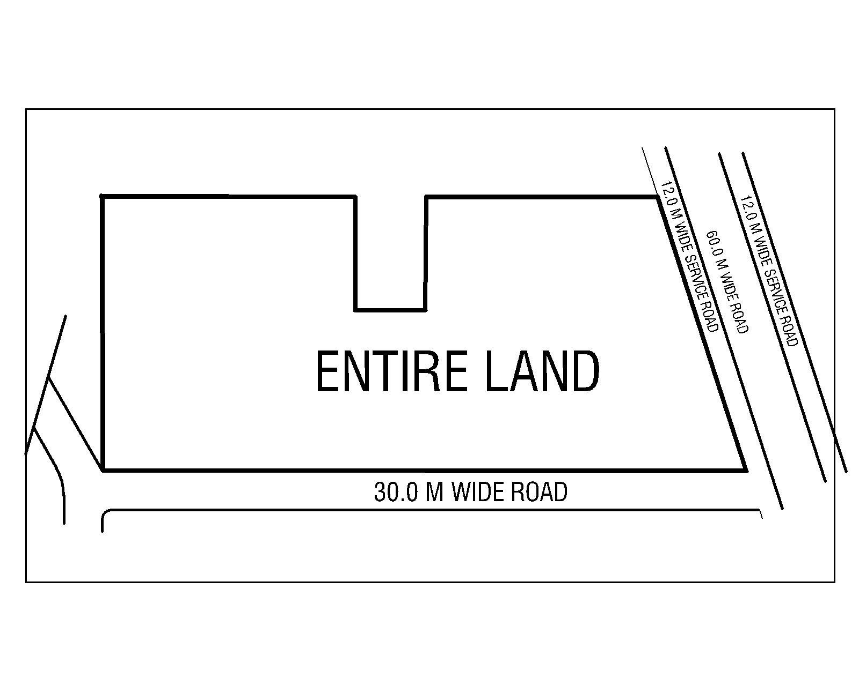

PART II OF SCHEDULE A

DEMARCATION OF RESIDENTIAL BLOCK LAND AND CONVENIENT SHOPPING BLOCK LAND

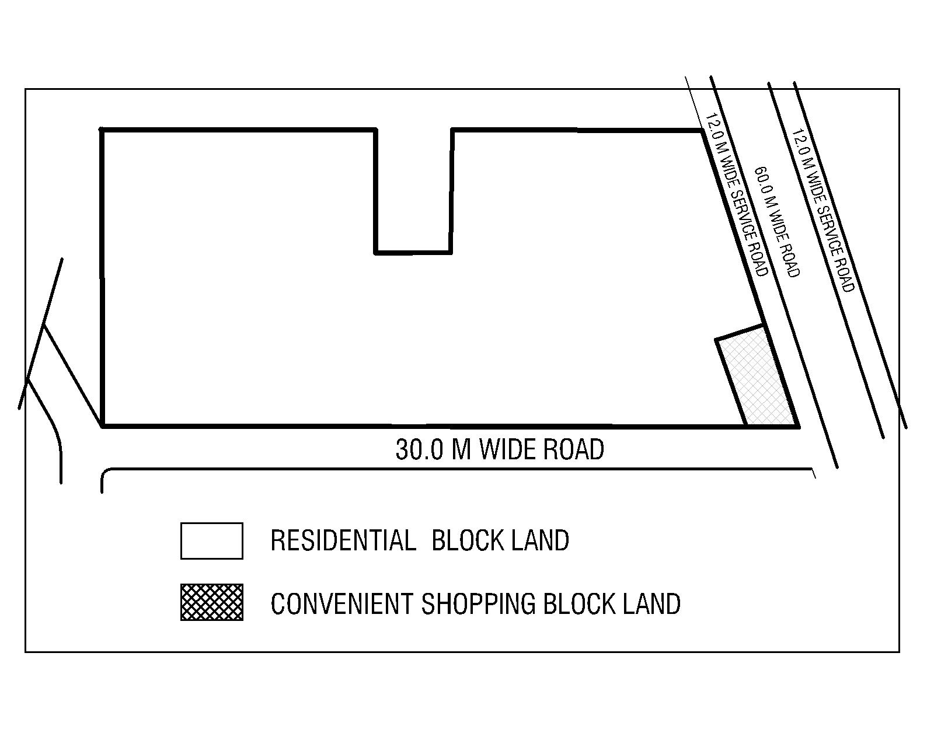

PART III OF SCHEDULE A

DESCRIPTION OF PROJECT LAND WITH DEMARCATION OF ASHIANA AAROHAM PHASE I

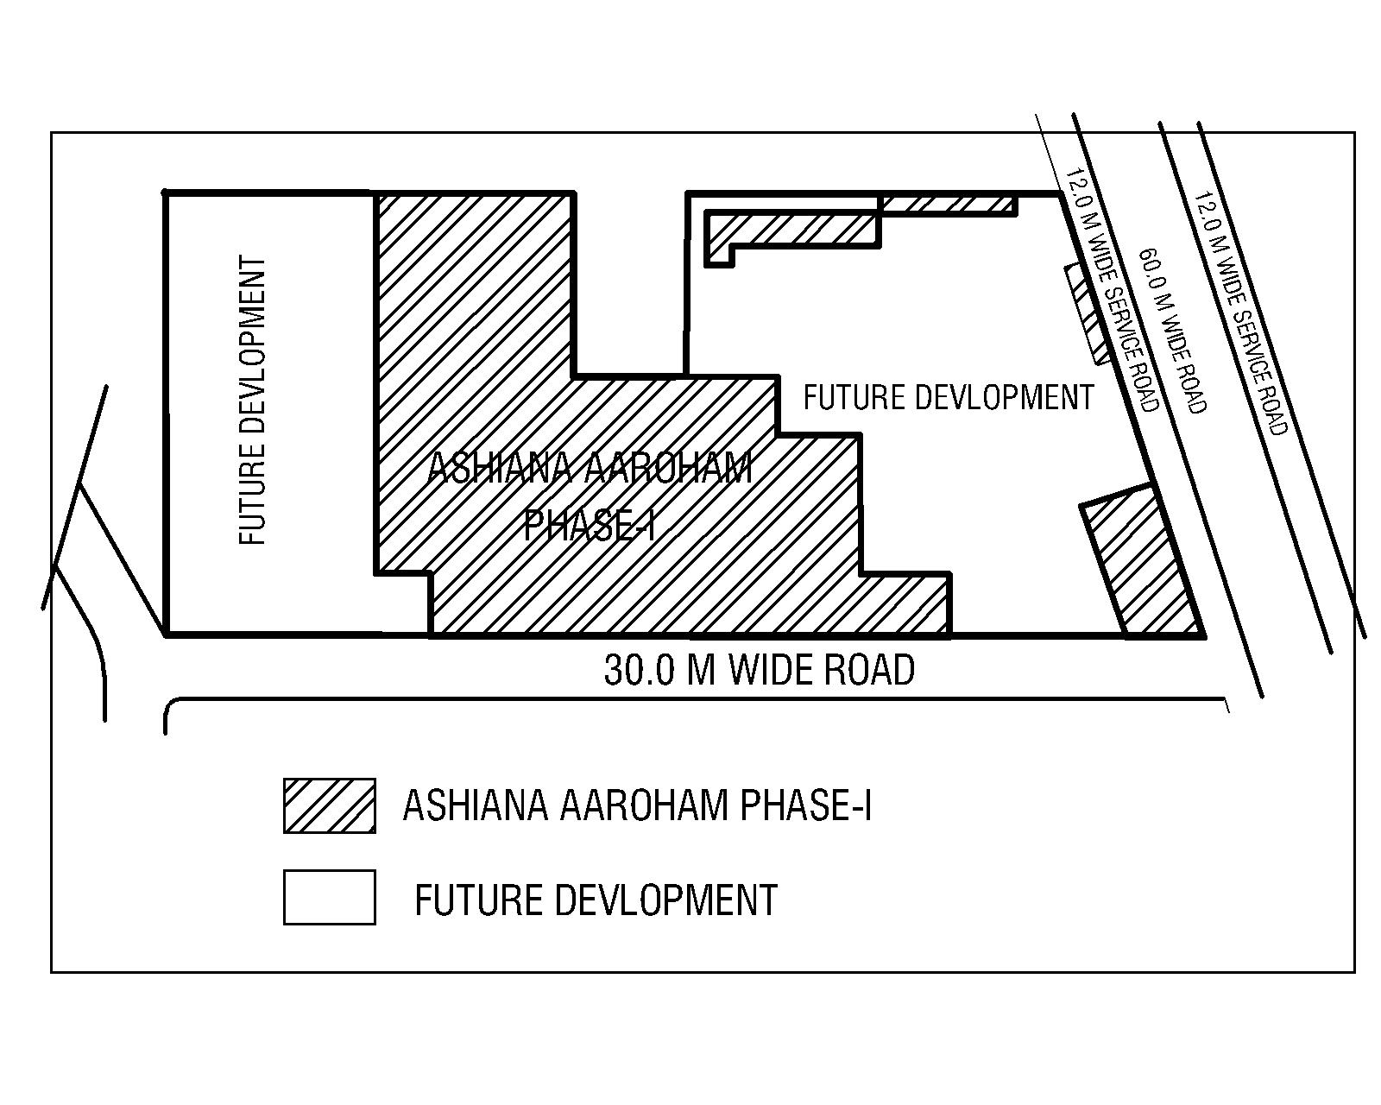

SCHEDULE B

DESCRIPTION OF THE UNIT

  - Unit No.
  - Floor:
  - Type:
  - Carpet Area: sq. mtr. ( sq. ft.).
  - Exclusive Balcony:
Balcony one: sq. mtr. ( sq. ft.)
Balcony two: sq. mtr. ( sq. ft.)

  - Type of Parking and Number of Parking-

SCHEDULE B-1

FLOOR PLAN

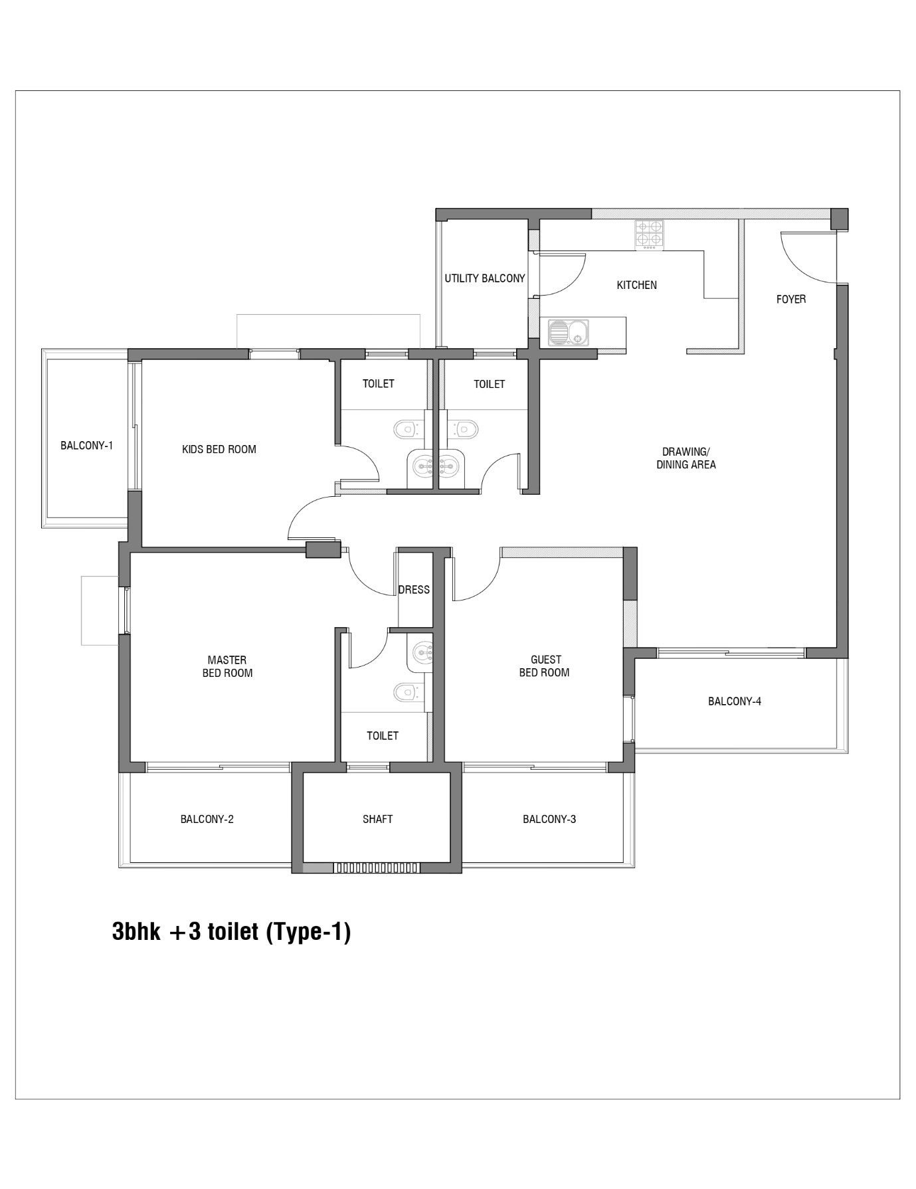
Carpet Area: _________________
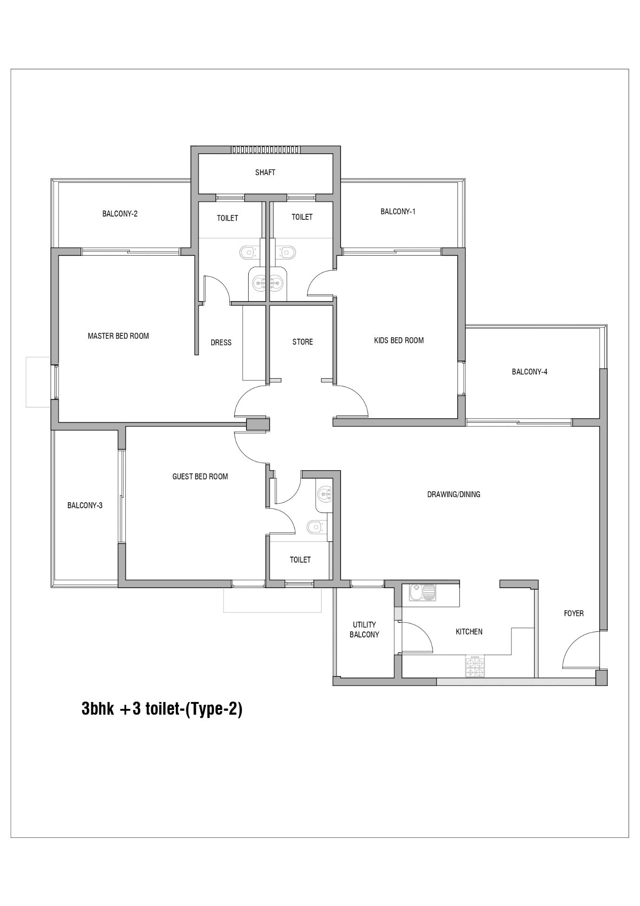

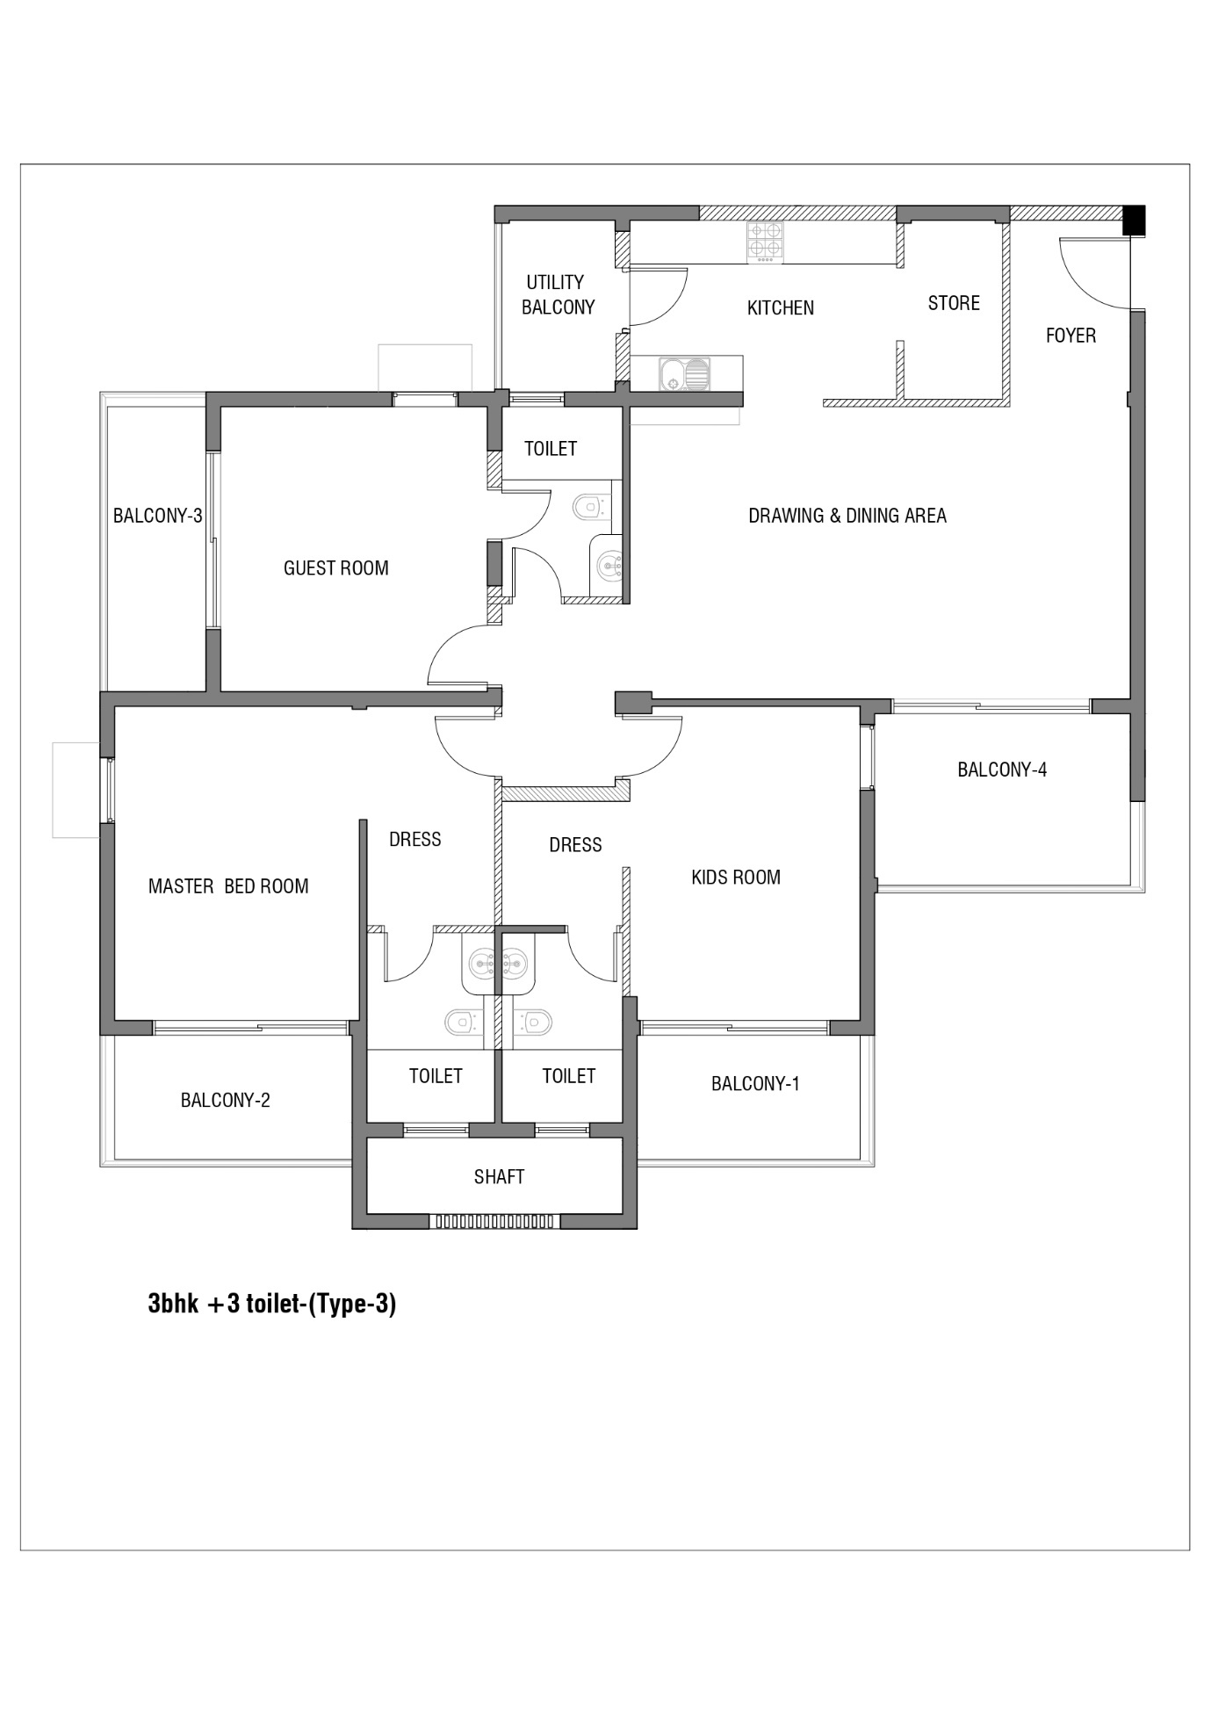

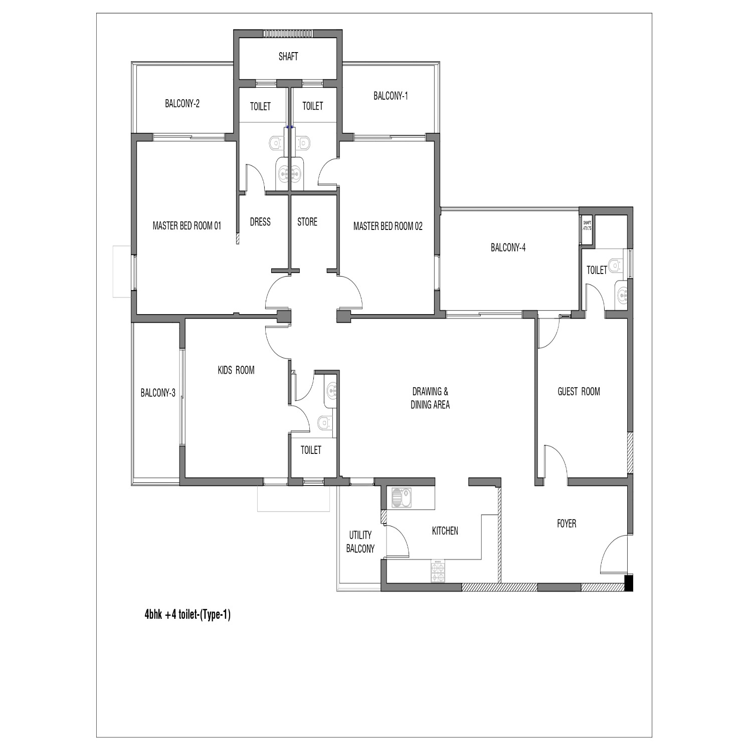

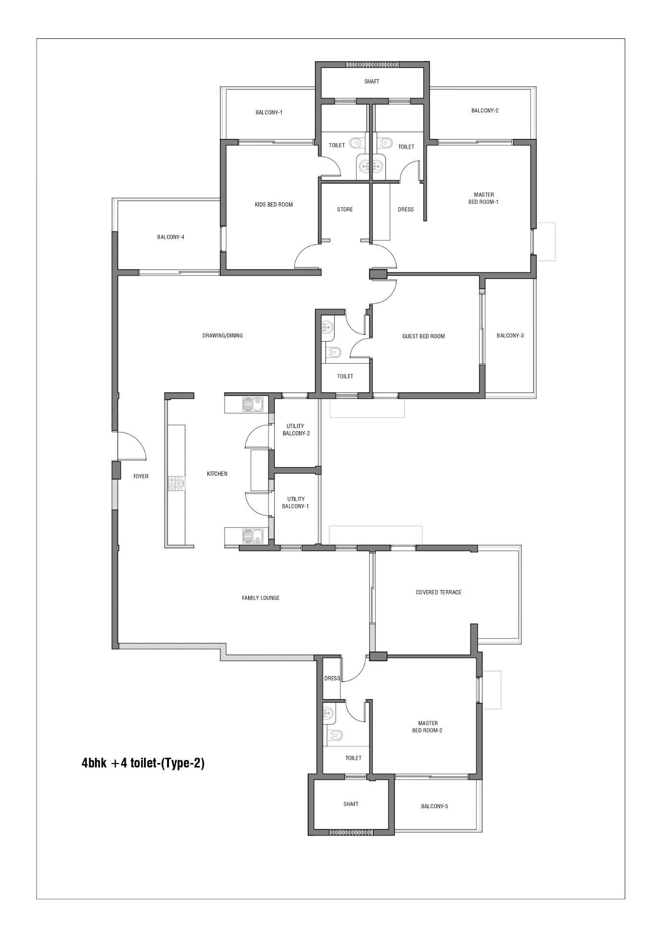

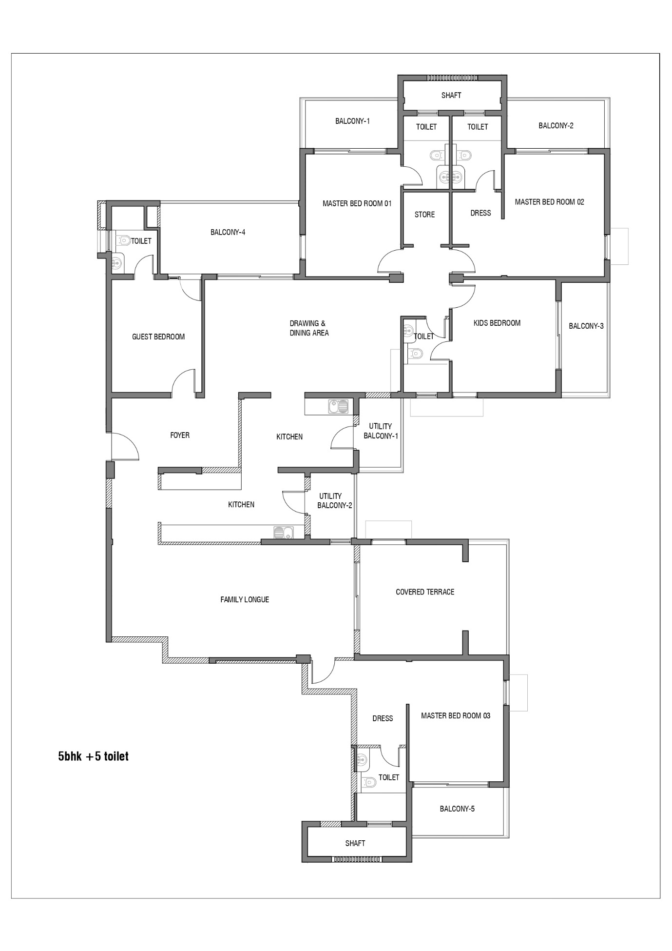

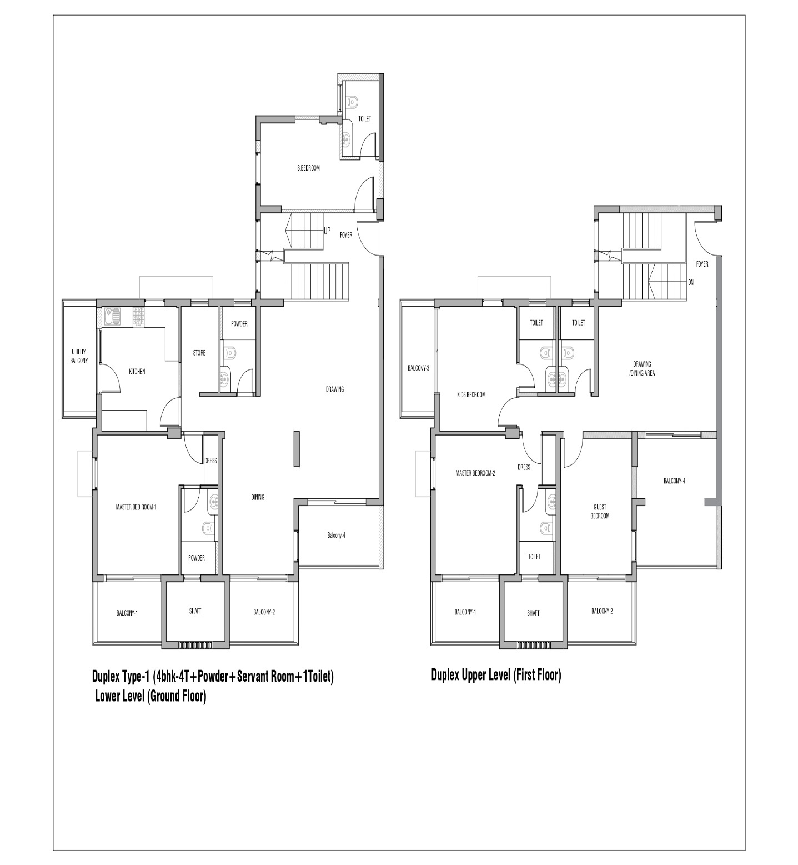

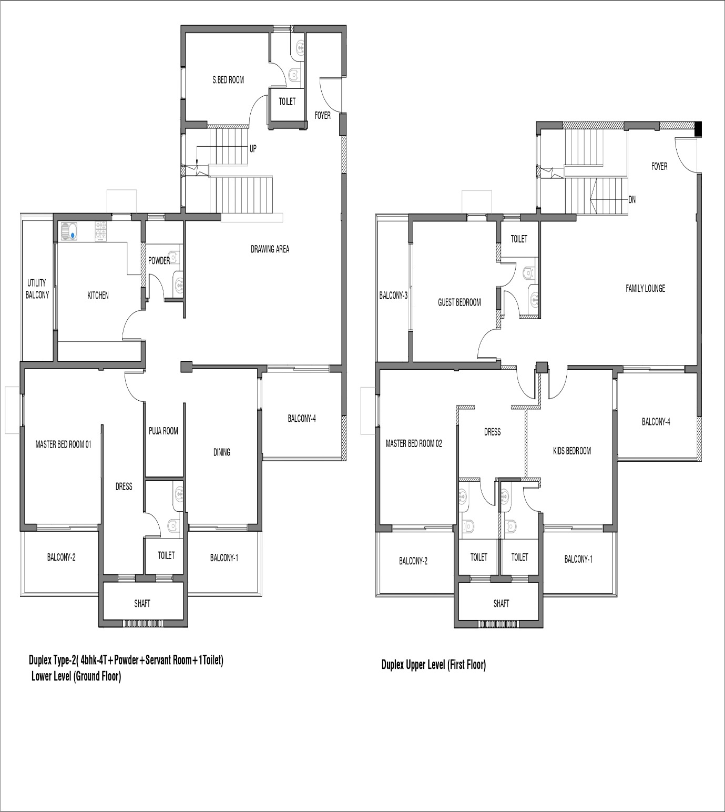

PART I OF SCHEDULE- C

TOTAL PRICE OF THE UNIT

The Total Price of the Unit is Rs. (Rs. only) is as follows:

I Price of the Unit including EDC/IDC after benefits Rs.________
ii. Taxes- SGST Rs.
- CGST Rs.
Total Price of the Unit including Taxes Rs.

PART II OF SCHEDULE C

PAYMENT PLAN

The Said Total Price of Rs. ________________ (Rupees ______________________Only) mentioned in Part-I of Schedule-C shall be paid by the Allottee to the Promoter in installments as follows.

Installment | Particulars | Percentage | Unit Price including EDC/IDC after Benefits | Taxes- SGST & CGST | Total Price of the Unit
1st | At the time of Booking along and allotment letter | <10%
2nd | After Signing of Builder Buyer Agreement i.e. on  commencement of construction | <10%
3rd | On completion of sub- structure | 7.5
4th | On completion of super- structure | 25
5th | On completion of Mechanical Electrical and Plumbing works | 10
6th | On completion of finishing | 20
7th | On completion of Internal development works | 12.5
8th | On Possession (Stamp duty, registration charges, miscellaneous expenses/fee etc.) | 5

PART I OF SCHEDULE D

COMMON AREAS, AMENITIES AND FACILITIES OF THE WHOLE PROJECT

- Sewer System and Sewer Treatment Plant
- UGT & Pump Room
- Electrical Sub Station
- DG Sets
- Basement
- Basement vehicle Parking within the limits of Residential Block
- Podium vehicle Parking within the limits of Residential Block
- Open vehicle Parking within the limits of Residential Block

PART II OF SCHEDULE D

COMMON AREAS, AMENITIES AND FACILITIES RESERVED FOR RESEDINTIAL BLOCK
1) Residential Block Land
2) Guard Room
3) Community Building
4) Swimming Pool
5) Sports Facilities
6) Kids Play Areas
7) Green & Landscape facilities
8) Basement vehicle Parking within the limits of Residential Block
9) Podium vehicle Parking within the limits of Residential Block
10) Nursery School/Learning Centre
11) Open vehicle Parking within the limits of Residential Block

Note-Any common areas and facilities located in Residential Block Land shall be reserved exclusively for Residential Block unless specifically mentioned as common area of the Whole Project and to be used by both Residential and Convenient Shopping Block

Part III OF SCHEDULE D
COMMON AREAS, AMENITIES AND FACILITIES RESERVED FOR CONVENIENT SHOPPING BLOCK

Convenient Shopping Block Land

Lobby, Staircases etc.

Note- Any common areas and facilities located in Convenient Shopping Block Land shall be reserved exclusively for Convenient Shopping Block unless specifically mentioned as common area of the Whole Project and to be used by both Residential and Convenient Shopping Block

PART I OF SCHEDULE E

COMMON AREAS, AMENITIES AND FACILITIES OF THE WHOLE PROJECT BEING DEVELOPED WITH SAID PROJECT

- Sewer Treatment Plant (Part)
- UGT & Pump Room (Part)
- Electrical Sub Station (Part)
- DG Sets (Part)
- Basement vehicle Parking within the limits of Residential Block
- Podium vehicle Parking within the limits of Residential Block
- Open vehicle Parking within the limits of Residential Block

PART II OF SCHEDULE E

COMMON AREAS, AMENITIES AND FACILITES RESERVED FOR RESEDENTIAL BLOCK BEING DEVELOPED WITH THE SAID PROJECT

- Residential Block Land
- Guard Room
- Community Building
- Swimming Pool
- Kids Play Area
- Green & Landscape facilities
- Basement vehicle Parking within the limits of Residential Block
- Podium vehicle Parking within the limits of Residential Block
- Open vehicle Parking within the limits of Residential Block

PART III OF SCHEDULE E

COMMON AREAS, AMENITIES AND FACILITES RESERVED FOR CONVIENENT SHOPPING BLOCK TO BE DEVELOPED WITH THE SAID PROJECT

Convenient Shopping Block Land
- Lobby, Staircases etc.

SCHEDULE-F

SPECIFICATIONS

- Foundation

Reinforced cement concrete, isolated & combined footings/ strip / raft foundation or load bearing rubble/ masonry or cast-in-situ bore piles and pile caps as per applicable Bureau of Indian Standards (BIS) codes. (Refer note 14-j)
- Superstructure

Reinforced cement concrete frame structure/Aluminum form work System with load bearing masonry structure in accordance with applicable earthquake zone and Bureau of Indian Standards (BIS) codes (refer note 14-j).
- Walls

- Internal: Walls of Clay Bricks/Fly ash Bricks/AAC Blocks/Solid concrete blocks/Hollow concrete blocks/R.C.C shear wall

- External: Same as above

- Finishes – Wall

- Units

- Drawing/Dining/Bedrooms: sand-cement plaster /coat of POP with coating of emulsion paint.
- Master and all other bathrooms: Ceramic tiles up to lintel beam bottom from floor level. Above the tiles - sand-cement plaster/ coat of POP with coating of emulsion paint.
- Kitchen: Dado Tiles 300x300 Ceramic tiles upto 0.60 meters from Quartz/Granite/Tile countertop. Above the tiles - sand-cement plaster/ coat of POP with coating of emulsion paint.

- Common Areas - Internal Wall: Lift lobby in basement, stilt/ground floor and upper floors: Granite and/or marble and/or Quartz stone and /vitrified tiles and/or ceramic tiles and/or cement sand plaster and/or other local stone and/or combination of any two or more items with emulsion paint finish (wherever applicable).

- Common Areas - External Wall: All external walls including roof terrace, open terrace, Cement sand plaster/POP punning/Primer with spray texture/coating and/or emulsion paint finish.

- Finishes –Floor
- Units

- Living/Dining, entrance foyer, corridor leading to bedrooms: Vitrified Tiles (600X600) or (800X800) or (600X1200) or (800x1600).

- Bedrooms and study room: Wooden texture tile, (145 x 600) or (600X600) or (800X800) or (145 x600) or (200x1000) or (196 x1200) or (200 x1200)

- Master Bedroom: Wooden texture Vitrified tiles. (196 x 1200) or (200 x 1000) or (200 x 1200)

- Master and all other bathrooms: Ceramic Tiles (300X300) or (300X600) other sizes up to (600X600) and/or combination, or
Wooden texture Tile (200 x 1200), (200 x 1000)

- Balcony: Ceramic Tiles (300X300), (298x298), (200 x 1200), (600x298) (600x300), or other sizes up to (450X450)/or combination) suitable quality glazed/matt finish/ or Wooden texture Tile (145 x 600)

- Open Terrace: Kota stone/other local stone/ceramic tiles of appropriate quality/stone mosaic floor.

- Staircase: Ceramic Tiles or Kota Stone or combination local Stone of appropriate size.

- Kitchen: Vitrified Tiles (600X600) or (800X800) or (600X1200) or (800 x 1600).

- Common Areas - Internal Floor

- Lift lobby in basement, stilt/ground floor and upper floors: Ceramic tiles or Kota stone/other local stone or Terrazzo Tiles of appropriate size or combination of ceramic tiles.

- Staircases and Staircase landing: Ceramic tiles of appropriate quality or semi polished Kota stone or any other local stone or combination of tiles and mentioned stone.

- Stilt area: Ceramic tiles of appropriate quality or semi polished Kota stone or any other local stone or combination of tiles and mentioned stone.

- Basement car parks and ramp: Cement concrete finish

- Ceiling

- Units

- Living/Dining, bedrooms, bathrooms, entrance foyer, study area/room, store, balcony corridor inside the units leading to bedrooms, kitchen & all bathrooms:

- Plastered with either-
  - sand-cement mortar / coat of plaster of Paris
  - gypsum plaster

- Pleasing shade emulsion paint (Plastic/Acrylic as per Architect's recommendation) finish of appropriate quality.

- False ceiling in Foyer, toilets & kitchen. Bedroom of each apartment for the services routing requirement only.
- Common Area

- Lift Lobbies: same as 6(i)

- Staircase, Common lobby, Corridor, Stilt area tower, Stilt area Podium:

plastered with either-
a) sand-cement mortar/ coat of plaster of Paris or
b) gypsum

- Pleasing shade cement paint /distemper/emulsion of appropriate quality (as per Architects recommendation)

- Basement car parks and ramp: Cement concrete surface finished with grey cement wash after appropriate chiseling/grinding/smoothening or exposed concrete finish

Notes:
- Tiles are generally laid with spacers of suitable width and joints are filled with cementitious grout/Epoxy or Suitable Material in (Drawing/Bedroom/ Dining/ Kitchen/Washroom/ Balcony as decided by Architect)
- Skirting of 75 to 100 mm wherever applicable
- Marble/granite/Quartz stone/Vitrified Tile Slab/same floor tiles in window -sill inside the room. Window -sill will be sand cement plastered and painted from outside.

- Windows

- Bedrooms, drawing/dining and kitchen: 2 to 3 track aluminum Anodized /powder coated /UPVC framed window, with 2 to 3 sliding panels depending upon size with 6/8mm toughened glass and only provision for fly mesh shutter. (No Fly mesh shutter)

- All bathrooms/powder room: Anodized /powder coated Top hung/louvered with frosted glass/pin head No fly mesh shutter is being provided.

- Doors shutter & Door Frame

- Main entrance: 2-hour fire rated MS/wooden/MS in wooden finish frames & shutter with handle and lock system & Fire rated magic eye viewer.

- Bedrooms, Study room, master and all other toilets: Door frames/Chaukhat in engineered wood in Laminate finish. With Wooden finish Flush door shutters.
- Kitchen: No entrance kitchen door is provided

- Utility Balcony: Ventilated door is provided

Notes
- Fixture detail: Door handle & Dead Lock in main door of standard make.

- Mortise lock with handle, Door stopper & tower bolt in all bedroom’s door.
- Mortise lock with handle with coin turn in all bathrooms and powder room.

- Bathrooms and kitchen

Sanitary wares and fixtures
    - All toilets except powder room

- 1 wash basin fitted under/over /above on marble/granite /Quartz/ Vitrified Tile slab counter, or 1 semi recessed wash basin factory moulded with same counter ledges mentioned.

- 1 floor mounted EWC/ wall hung EWC with dual flush type vitrified /concealed cistern with seat and seat cover.

- A glass partition as per design of the Architect to segregate shower area from rest of the toilet shall be provided in all toilets

- Vanity below Washbasin Counter in only Master bedroom toilet.

- A single lever half/quarter turn CP basin mixer in wash basin, a single lever wall mixer with overhead shower, hand shower only in master bedroom and a spout in shower area.

- 1 CP angle valve along with chrome plated PVC semi rigid/flexible health faucet of standard make.

- 2 CP angle valve of standard make for in and out of hot water geyser

- 2 angle valves for water connection to wash basin and 1 angle valve for water connection to flushing cistern and 1 bottle trap of standard make PTMT material

- 1 towel rack shall be provided in all toilets.

- Providing Exhaust Fan in all toilets.

- Providing Geysers in all toilets.

- Mirror will be provided in all Toilet/bathroom size as per drawing.

- Staff toilet (wherever applicable)

- 1 floor mounted EWC with 6 liter capacity dual flush type PVC cistern with white/off white PVC/UPVC seat and seat cover
- 1 wash basin and a PTMT framed mirror as per drawing.
- 1 Pillar Cock in wash basin for cold water only of standard make
- 1 bib tap for cold water and 1 bib tap for hot water of standard make are provided in bathing area
- 1 angle valve for water connection to wash basin and 1 angle valve for water connection to flushing cistern and 1 bottle trap of standard make PTMT material.

- Kitchen

- 1 stainless steel sink with single/double bowl and a drain board.
- 1 swivel type sink mixer
- 2 CP angle valve for in and out of hot water geyser.
- 1 CP angle valve for water purifier unit/RO under counter
- Provision for Piped PNG /LPG gas with PNG/LPG meter will be provided.
- Kitchen cabinets with HOB, Chimney, Dishwasher, Microwave Oven, OTG, water purifier unit/RO under counter ,Geyser & Exhaust fan.

Notes
Brand/make of bath fixtures
- All Bathrooms except staff room toilet

- Sanitary wares: Hindware/Roca/Kohler/Jaquar/American Standard RAK/Vitra or equivalent
- Bath Fittings:

  - Basin mixer, wall mixer and shower of Jaquar/Roca/American Standard/ Grohe or equivalent.
  - Other angle valve either of CP or PTMT of Standard make like Jal/Continental/Prayag or equivalent.

- Staff room toilet (wherever applicable)
- Sanitary wares: Jaquar /Cera/Neycer/Parryware or equivalent
- Bath fittings:

- Pillar Cock JAL/Continental or equivalent,

- Other angle valve either of CP or PTMT of standard makes Jal/Continental/Prayag or equivalent.

- Kitchen
Water supply fittings:
  - sink mixer of Jaquar/Roca/American Standard/Grohe or equivalent.

  - Other angle valve either of CP or PTMT of Standard make like Jal/Continental/Prayag or equivalent.

- Electrical Installation and Fittings

    - All electrical wiring in concealed conduits with copper wires. Convenient position & distribution of light and power plugs and provision of electrical for HOB, Chimney, Microwave Oven, OTG above platform and Dishwasher, Under counter RO electrical point below counter in kitchen.

    - Modular electrical switches with sockets and fan regulators of SSK/Anchor/Panasonic/Northwest/Legrand or equivalent

- Cable TV Point will be provided in Drawing/dining & in all bedrooms, Telephone Points will be provided in drawing /dining room and in Master bedroom only. The intercom Provision will be provided through the authorized phone company or EPABX. Facility of DTH antenna installation for each unit is allowed only on the terrace and not in front of individual units.
Provision for Internet routers will be done at suitable location inside apartments.

- Surface Driveway and car parking

- Stone and/or pavers and/or tarmac and/or concrete to external driveway at designated areas.

- Additional items

- Security: Boom Barrier for vehicular barrier, Closed Circuit Television System (CCTV)Camera/ANPR to project entrance, block Entrance and Club house.

- Balcony and staircase railing: Balcony Metal/wall railing height is 1100 to 1200 mm and stair Metal/wall railing height is 1000mm.

- Power back up: Diesel Generator sets of appropriate capacity to provide full back-up into common areas & up to 8 KW in 3BHK ,4BHK and 12KW in 4BHK (refuge area) ,5 BHK, Duplex units.

- Washing machine: Provision is given in a suitable location.

- ACs-

- Fully fitted Invertor Air conditioners hot and cool on 3BHK ,4BHK apartments all bedrooms and two in living/Dining room with copper piping of suitable length along with MS Brackett for outdoor units
- Fully fitted Invertor Air conditioners hot and cool On the Refuge floor 4BHK ,5BHK apartments, all bedrooms and two in living/Dining room & two in family lounge with copper piping of suitable length along with MS Brackett for outdoor units
- Fully fitted Invertor Air conditioners hot and cool On the Duplex apartments, all bedrooms and two in drawing/living room, one in Dinning. & two in a family lounge with copper piping of suitable length along with MS Brackett for outdoor units

- Fresh Air Unit - Single unit of treated fresh air system will be provided in 3 BHK and 4 BHK apartments.

Double units of treated fresh air system will be provided on the refuge floor for
4 BHK and 5 BHK apartments, and in duplex apartments.

- Cloth Hanger will be provided on one balcony only.

- Notes/Disclaimers

- Wall: No tiles behind/below kitchen cabinets, Wall surface above the false ceiling may be left in its original bare condition.

- Marble, Limestone and granite are natural stone materials containing veins with tonality differences. There will be color and markings caused by their complex mineral composition and incorporated impurities. While such materials can be pre-selected before installation, this non-uniformity in marble, limestone or granite as well as non-uniformity between pieces cannot be totally avoided. Granite is pre-polished before laying and care has been taken for their installation. However, granite, being a much harder material than marble cannot be re-polished after installation. Hence some differences may be felt at joints. The tonality and pattern of marble, limestone or granite selected and installed shall be subject to availability.

- External Paints: External plastered surfaces of the buildings are painted of suitable quality as decided by the Architects. Paints are manufactured product from chemicals and specific grade of minerals/natural stone product. After application this paint is exposed to weather conditions. Ultraviolet ray and weather conditions will affect life and sheen of the product and also would cause damage to the expected/designed protective properties of paints. Therefore, periodic maintenance including redoing of paints would be inevitable.

- Materials, Fittings, Equipment, Finishes, Installation and Appliances: The brand, colour and model of all materials, fittings, equipment, finishes, installation and appliances supplied shall be provided subject to architect's selection, market availability and the sole discretion of the vendor/developers.

- Air Conditioning System: split air conditioner in drawing dining area & bedrooms are being provided. For Split A/C assigned spaces are earmarked on the elevation of the building for ease of access and to create uniformity for aesthetic purpose.

- Timber: Timber is a natural material containing grain/vein and tonal differences. Thus, it is not possible to achieve total consistency of color and grain in its selection and installation. Timber has inherent property to react along with atmospheric changes, which results bending, twisting and cracking if not maintained well consistently.

- Internet Access & Cable Television: If the Purchaser requires internet access & Cable Television, the Purchaser will have to make direct arrangements with the Service Provider /or such relevant entities/authorities for services to the Unit and to make all necessary payment.

- Glass: plain/clear/frosted/tempered/toughened, is widely used in residential developments and may break/ shatter due to accidental knocks or other causes. In addition, glass is manufactured material, and the Purchaser may wish to note that it may not be 100% free from impurities. These impurities are not avoidable with quality checks and balances.

- Tiles: Tiles are manufactured from special kind of clay and other materials. Baking on very high temperature is an integral stage of the manufacturing process and therefore, shades and flatness of each lot varies a little bit. Hence, selected tile sizes and tile surface flatness cannot be perfect. Different quality assurance organizations like ISO 10545-2/ Singapore standard SS483:2000 had mentioned acceptable ranges. We, at Ashiana, have been taking utmost care while receiving materials and while installing them to minimize these issues but they can never be avoided completely due to inherent properties of the material and therefore consistency in flatness, sizes and minor chips on edges cannot be guaranteed. To minimize such issue tiles are laid with spacers.

- Design Experts: Professionally qualified practicing consultants in the field are deployed to design different functions in compliance to applicable norms and guidelines. These functions are a) Architecture b) Structure c) Plumbing d) Landscape e) Fire Fighting and e) Power & Electrical. Design parameters set by such experts and applicability of their drawings and decisions are treated as final.

- As per structural design principles, structures are allowed to deflect in different allowable loading/atmospheric/ground settlement/seismic parameters. Since masonry and RCC members behaves differently in such situations, therefore hair cracks in different components of the building are inevitable. These cracks are more visible in plastered surface of the masonry work. While conventionally recognized precautionary measures will be undertaken diligently but complete dis-appearance of such cracks cannot be ascertained.

- Brick work, plaster and application of putty/POP over plastered surface are manual activities. As of date, no machines are found successful to execute these activities without extensive human involvement. Hence, despite all quality processes in the job, undulation, out in plumb to a certain extent cannot be avoided completely.

- While every reasonable care has been taken in preparing the brochure and in constructing the models and show flats, the Developer and the Marketing Agents cannot be held responsible for any inaccuracies or omissions. Visual representations, models, show flat displays and illustrations, photographs, art renderings and other graphic representations and references are intended to portray only artists’ impressions of the development and cannot be regarded as representations of the fact. Floor areas are approximate measurements and are Subject to final survey.

- All information, specifications, renderings, visual representations and plans are correct at the time of publication and are subject to changes as may be required by the Promoter and/or the competent authorities and shall not form part of any offer or contract nor constitute any warranty by the Promoter and shall not be regarded as statements or representation of fact. All facts are subject to amendments as directed and/or approved by the building authorities. All areas are approximate measurements only and subject to final survey. The Agreement to sell shall form the entire agreement between us as the Promoter and the Allottee and shall supersede all statements, representations or promises made prior to the signing of the Agreement to sell and shall in no way be modified by statements, representations or promises made by us or the marketing agents.

ANNEXURE I

BOARD RESOLUTION

